Accounting in Kazakhstan:

The Chart of Accounts, IFRS/IAS & Tax Code.

Introduction

During this session you will get a general understanding of accounting procedures and practices in Kazakhstan. Discussion will be started from an introduction to the International Financial Reporting Standards/ International Accounting Standards (IFRS/IAS) (four-digit coding, groups of accounts, etc.) adopted by Kazakhstan in 2006. You will also get an overview of methodological recommendations to the Chart of Accounts, and their usage for accounting work. This discussion will be followed by the introduction to an electronic version of the Chart of Accounts, and its practical use in 1C: Accounting 8.2 (by adding new elements, changing the level of analytics, and putting additional parameters).

As an accountant you have to be fully aware about Kazakhstan’s legislation related to accounting. Legislation base is updated on a regular basis, and it is crucial to be aware about all changes in the legislation. Basic legislation acts governing accounting procedures in Kazakhstan are: Law on Accounting, IFRS/IAS and their interpretations, Tax Code (updated on annual basis), Customs legislation, and different instructions.

On our web site you can find full texts of: the Chart of Accounts and methodological recommendations to it plus its English equivalent, the full text of IFRS/IAS with interpretations, examples and methodological recommendations, the full text of Kazakhstan’s Tax Code, lists of correct transactions, and samples of accounting documents' forms used in different accounting situations (payroll accounting, accounting for fixed and intangible assets (with blanks of acts and stock-taking documents), accounting for cash operations (receipt and expenses orders, journal of registering cash documents, cash-book), etc. Most of these documents have been implemented in 1C: Enterprise (but not all!), and have their electronic equivalents. This set is more than enough for you now to be an equipped accountant.

Please note one more time that methodological base is updated on a regular basis that mean you must always check for the latest versions of documents in order to follow accounting procedures properly.

Learning Objectives

This session will help you to learn:

- Organization and structure of the Working Chart of Accounts
- How to make changes in the Chart of Accounts
- How to add new accounts
- How to configure correctly new and existing accounts
- How to set up additional properties of analytics
- Purpose and usage of International Financial Reporting Standards/International Accounting Standards (IFRS/IAS)
- Basic forms of accounting documents used in Kazakhstan
- Organization of Kazakhstan's Tax Code
- Kinds of taxes existing in Kazakhstan, and major information about them

Step-by-Step tasks
1. Organization and Structure of the Chart of Accounts (IFRS).
A new instruction providing guidelines for developing the working Chart of Accounts and introducing new forms of financial reports (Balance Sheet, Income Statement, Cash Flow Statement, and Statement of Changes in Owner's Equity) is in power from January 5, 2006. According to this instruction the new Chart of Accounts developed in accordance with IFRS has 4-digit account codes and shows assets in the order of decreasing liquidity:
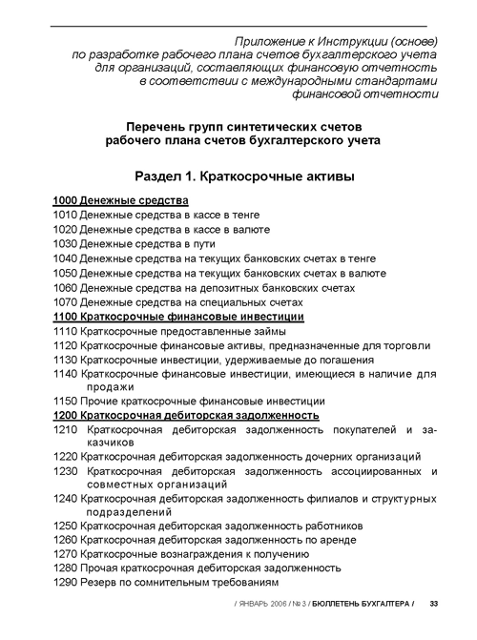
Under this Chart of Accounts, there are 8 sections:
- Section 1: Short-Term Assets
- Section 2: Long-Term Assets
- Section 3: Short-Term Liabilities
- Section 4: Long-Term Liabilities
- Section 5: Capital and Reserves (Equity)
- Section 6: Revenues
- Section 7: Expenses
- Section 8: Accounts of Production
Section number gives the first digit of account's code. Each section contains subsections that form the second digit of the code:
- Section 1: Short-Term Assets
  - Subsection 1000: Money
  - Subsection 1100: Short-Term Financial Investments
  - Subsection 1200: Short-Term Accounts Receivable
  - Subsection 1300: Inventories
  - Subsection 1400: Current Tax Assets
  - Subsection 1500: Long-Term Assets for Sale
  - Subsection 1600: Other Short-Term Assets
The third digit of the code represents account’s group:
- Section 1: Short-Term Assets
  - Subsection 1000: Money
    - Account 1010: Money in Cash Register (in tenge)
    - Account 1020: Money in Cash Register (in foreign currency)
    - Account 1030: Money On the Way
    - Account 1040: Money on Current Bank Accounts (in tenge)
    - Account 1050: Money on Current Bank Accounts (in foreign currency)
    - Account 1060: Money on Deposit Bank Accounts
    - Account 1070: Money on Special Accounts
If accountant needs more details for a particular group (e.g. group 2410 representing Fixed Assets), it can be broken down into individual accounts that should appear in the order of decreasing liquidity: 2411 – Vehicles, 2412 – Machines and Equipment, etc.)
Short Methodological Recommendations are included into Instruction on developing the Working Chart of Accounts, as well. They denote meanings of individual groups.
NOTE: This Chart of Accounts does not contain section for off-balance-sheet accounts. It is explained by the fact that according to IFRS companies can introduce new accounts at their wish, complementing existing accounts, and consequently there is no need in off-balance-sheet accounts.

When you start preparing accounting transactions, to avoid mistakes, it’s also important to know the following classification of accounts:
Active accounts show increase on debit, decrease on credit and always have debit balance. Examples of Active Accounts include Money, S-T/L-T Financial Investments, S-T/L-T Receivables, Inventories, Fixed/Intangible Assets, Work/Construction in Progress, Current Tax Assets, Other Assets, Outstanding Capital, Expenses, and Accounts of Production.
Passive accounts show increase on credit, decrease on debit and always have credit balance. Examples of Passive Accounts include Depreciation/Amortization, S-T/L-T Financial Obligations, Tax/Deferred Tax & Other Obligations, S-T/L-T Payables, Declared Capital, Reserves, and Revenues.

Examples of transactions involving Active/Passive Accounts are shown below:

1010 (A) – 1040 (A) – money received into Cash Register from Settlement Account
1040 (A) – 1010 (A) – transferred money from Cash Register to Settlement Account
1250 (A) – 1010 (A) – money given to advance holder

5020 (A) – 5010 (P) – declared authorized capital
1040 (A) – 5020 (A) – received money as contribution to authorized capital

3310 (P) – 1040 (A) – paid to supplier for Fixed Assets
2410 (A) – 3310 (P) – received Fixed Assets

Example of using sub–accounts for one of accounts representing fixed asset is shown below (alternative way is to use subconto 'Fixed Assets'):

2412.1 – machines and equipment in administrative division
2412.2 – machines and equipment in production division

2412.2 – 2412.1 – transferred PC from administrative to production division

You may also save some time for you by remembering frequently used groups of accounts first:

Money:

1010 – Cash Register (in tenge)
1020 – Cash Register (in foreign currency)
1030 – Money on a Way
1040 – Settlement Account
1050 – Currency Settlement Account

Fixed/Intangible Assets & Depreciation/Amortization & Reserves

2410 – Fixed Assets (can be detailed further by opening additional accounts)
2420 – Depreciation of Fixed Assets (can be detailed further)

2730 – Other Intangible Assets – except Goodwill (2710)
2740 – Amortization of other IA – except Goodwill (2720)

5320 – Reserve on re–evaluation (can include: Additional outstanding capital from re–evaluation of FA)

Inventories

1310 – Raw Materials
1320 – Finished Goods
1330 – Goods
1340 – Production in Progress
1350 – Other Inventories

Receivables/Payables

1210 – Short–Term A/R (краткосрочная дебиторская задолженность)
2110 – Long–Term Receivables (долгосрочная дебиторская задолженность)

1250 – Short–Term A/R from employees (краткосрочная дебиторская задолженность работников)
2150 – Long–Term Receivables from employees

3310 – Short–Term A/P (краткосрочная кредиторская задолженность)
4110 – Long–Term Payables (долгосрочная кредиторская задолженность)

Revenues/Expenses

6010 – Income from Realization of Goods, Works, and Services
6020 – Return of Goods Sold
7010 – Cost of Goods Sold (COGS)

7210 – General (and Administrative) expenses
7110 – Expenses on Realization of Goods, Works and Services

6210 – Income from retirement of assets (can include: Income from retirement of FA)

6250 – Gain of favorable exchange rate difference
6280 – Other income

6130 – Income from financial leasing

7430 – Expenses on unfavorable exchange rate difference
7470 – Other expenses

Accounts of Production

8010 – Main Production (can include: Materials (in production), Remuneration of labor of Production Workers, Deductions, etc.)

8040 – Overhead Expenses (can include: Repairing of FA, Depreciation of FA/Amortization of IA, Utility Services, Rent Payments, etc.)
Issued Capital

5010 – Declared Capital (учитывается в зависимости от формы организации по группам счетов)
5020 – Outstanding Capital

Advances Given/Received

1610 – Short–Term Advances Given
2910 – Long–Term Advances Given

3510 – Short–Term Advances Received
4410 – Long–Term Advances Received

Loans

3010 – Short–Term Bank Loans
4010 – Long–Term Bank Loans

Rent/Interest

3360 – Short–Term rent obligations
4150 – Long–Term rent obligations

3380 – Short–Term Interest payable
4160 – Long–Term Interest payable

7310 – Interest expense

Obligations on Remuneration of Labor

3350 – Short–Term obligations on remuneration of labor
4170 – Other Long–Term Payables

Taxes (Payable) & Obligations on Other Obligatory/Voluntary Payments

3110 – Corporate Income Tax (payable) (NOTE: 7710 – Expenses on Corporate Income Tax)
3120 – Personal Income Tax
3130 – VAT (payable) (NOTE: 1420 – VAT to offset)
3140 – Excise Taxes
3150 – Social Tax
3160 – Land Tax
3170 – Tax on Vehicles
3180 – Property Tax

3210 – Obligations on Social Insurance
3220 – Obligations on Pension Payments

Retained Earnings/Outstanding Loss

5410 – Income/Loss for the current year

2. Organization and Structure of the Chart of Accounts (KAS).
Some time will pass unless all Kazakhstan's companies will implement IFRS/IAS. It is explained by the fact that the first financial reports according to new standards for companies making transition in January 2006 are expected to be prepared only by December 31, 2007, as well by the costly procedure of rewriting accounting policy, conducting double-standard accounting for some time, making transformation entries, and delays in availability of accounting software implementing new standards.
That is why we will also briefly consider the Kazakhstan's Chart of Accounts that was accepted in January 2003 and still used by some companies in Kazakhstan:
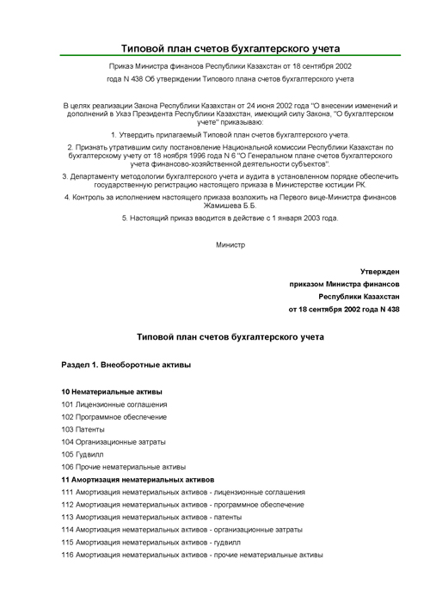
This Chart of Accounts follows three-digit classification of accounts' codes. Under this Chart of Accounts, there are 10 sections:
- Section 1: Fixed Assets
- Section 2: Inventory
- Section 3: Accounts Receivable and Other Assets
- Section 4: Financial Investments and Money
- Section 5: Owner's Capital
- Section 6: Liabilities
- Section 7: Revenues
- Section 8: Expenses
- Section 9: Accounts of Production
- Section 10: Off-Balance Sheet Accounts

Section number gives the first digit of account's code. Each section has subsections that have 2-digit codes, for example:
- Section 1: Fixed Assets
  - Subsection 10: Intangible Assets
  - Subsection 11: Amortization of Intangible Assets
  - Subsection 12: Fixed Assets
  - Subsection 13: Depreciation of Fixed Assets
  - Subsection 14: Investments

Subsection number gives the second digit of account's code. Finally, individual accounts are coded in order within each subsection, for example:
- Section 1: Fixed Assets
  - Subsection 10: Intangible Assets
    - Account 101: License Agreements
    - Account 102: Software
    - Account 103: Patents
    - Account 104: Organizational Expenses
    - Account 105: Goodwill
    - Account 106: Other Intangible Assets

Individual account's order number gives the third digit of account's code. This classification is very convenient and allows quickly identifying and finding necessary accounts within the Chart of Accounts.

3. Implementation of the Chart of Accounts in 1C: Accounting 8.2.
The Chart of Accounts is a main component of typical configuration. Structure of accounts and their properties determine the accounting methodology realized in the given configuration, and influence practically all parts of configuration concerning book-keeping.
Given configuration of 1C: Accounting 8.2 contains an extended electronic implementation of the Chart of Accounts authorized by the resolution of the minister of finance of the Republic of Kazakhstan from December 22, 2005, #426 "On implementing the Working Chart of Accounts":
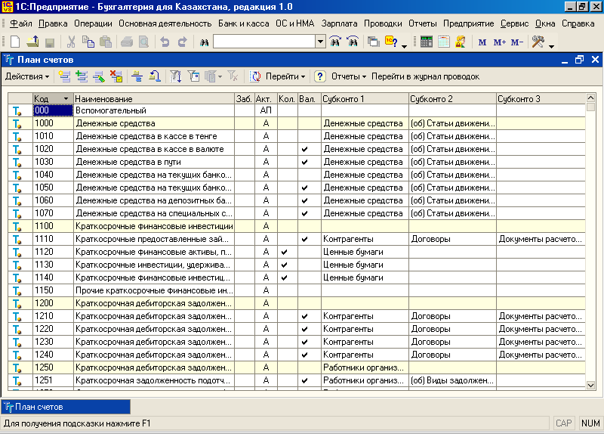

Electronic version of the Chart of Accounts allows an unlimited number of accounts (groups) of the first order to be entered into it. If users want to create their own accounts to reflect company-specific operations, they can create appropriate groups, and later create up to 10 accounts within the group (under KAS structure of the Chart of Accounts was strictly regulated, but there were an option to create off-balance-sheet accounts for operations for which there were no appropriate balance accounts. Current configuration leaves this option, even if this is not regulated by IFRS, and you can find examples of such accounts in sections 9010 – Rented Fixed Assets…
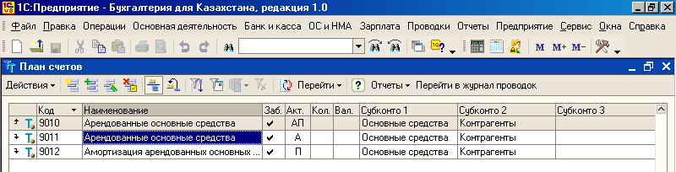

… and 9020 – Materials accepted for processing):
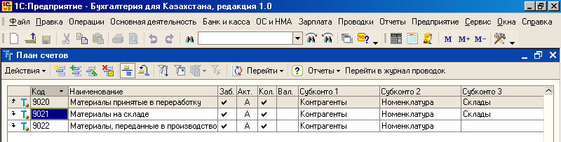

Below is a list of potential accounts that can be created in the Chart of Accounts (if necessary):

Account Name
Rented Fixed Assets
Inventory Accepted for Storing
Materials Accepted For Processing
Goods Accepted for Commission/Consignment
Equipment Accepted for Installation
Forms of Strict Reporting
Loss From Bad Debtors Written Off
Provisions of Obligations and Payments Received
Provisions of Obligations and Payments Given
Depreciation of Fixed Assets
Fixed Assets Leased to Other Companies
…

This list can be easily extended to face particular company's needs.

If company needs further detail on specific account (group), it can create additionally sub-accounts for selected accounts (e.g. create accounts 2411 – Vehicles, 2412 – Machines and Equipment, and then for account 2412 create sub-accounts: 2412.1 – machines and equipment in administrative division, 2412.2 – machines and equipment in production division. etc.).

Permissions for creating sub-accounts are set up in configuration mode, and total number of sub-accounts allowed for specific account is determined by the account mask (in current configuration usage of sub-accounts is prohibited):

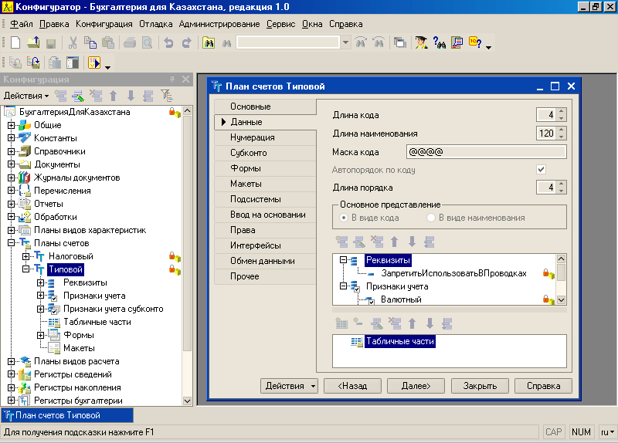

At the beginning of the Chart of Accounts there is an auxiliary account “000” which does not exist in the Working Chart of Accounts. This account is used to enter initial balances into the program for organizations, which have had accounting transactions for prior periods. For example, if company wants to show reminders of money in cash register from previous periods, it will enter the following transactions: D 1010 C 000 :
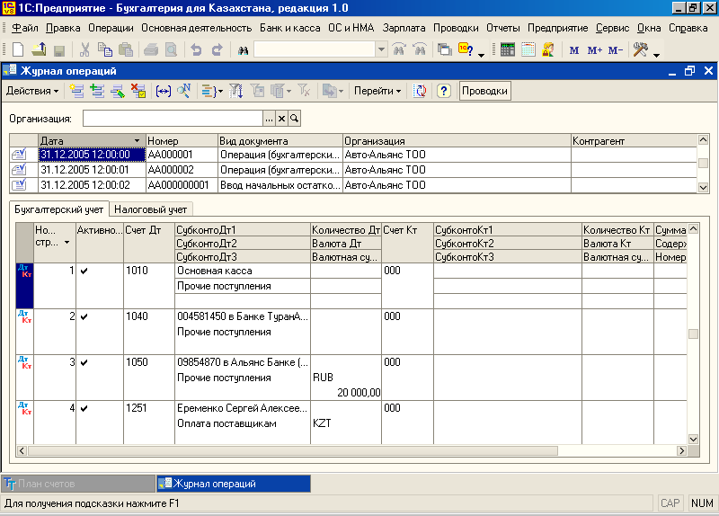

Each group (or individual account) in the Chart of Accounts' window has a pictogram resembling blue letter "T" in the beginning of a line. Accounts created in configuration mode (these accounts are called predefined accounts) have a yellow dot to the right from icon: . Predefined accounts can be deleted only in configuration mode. It is explained by the fact that significant part of documents, specialized and regulated reports provided with configuration are focused on the certain properties of concrete accounts, therefore any unintentional change to the account can make a significant harm to the proper functioning of configuration as a whole.
While working in user’s mode, it is not allowed for predefined accounts to change attributes of Active/Passive accounts, and change settings of quantitative and currency accounting. From the other hand, for predefined accounts users can change account’s code, title (accounts name or description), change subordination of account, as well as enter or change additional levels of analytics (subconto):

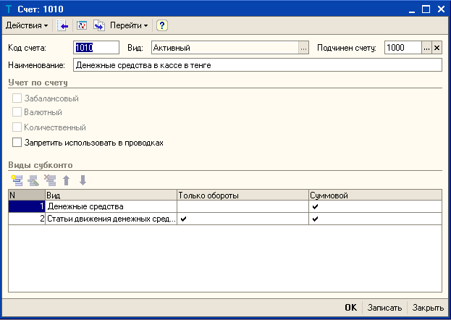
Users can also add their own accounts to the COA both in user’s and in configuration mode:
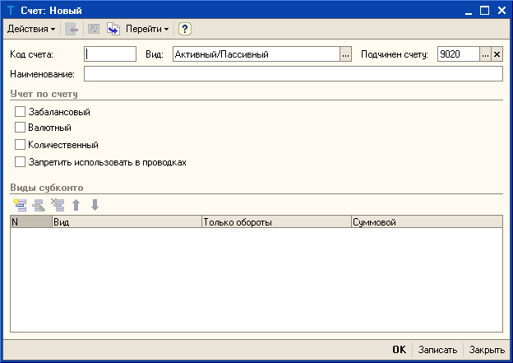
For accounts entered in user’s mode it is allowed to make any changes, as well as delete them.
To make navigation easier, each section of the Chart of Accounts (e.g. 1000 – Money, 1100 – Short-term Financial Investments, etc.) is highlighted with yellow color. Moreover, it is possible to hide all accounts and leave only section numbers to navigate through the Chart of Accounts quickly.
If button Hierarchical List is pressed, all accounts included into each subgroup will be hidden:
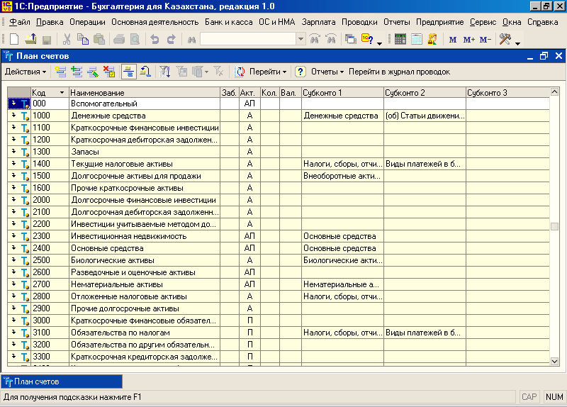

In this case, if you want to see the accounts included into particular subgroup, double-click its icon. Subgroup will be opened (in a folder manner), and accounts will be shown:
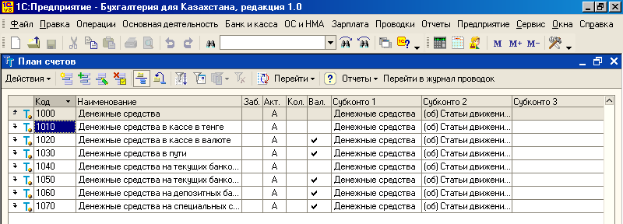

4. Working with Attributes.
Now pay attention to other columns presented in the Chart of Accounts.

- Attribute Off-balance-sheet ("Заб.") allows creating accounts with single-posting property – when you will be entering new transactions there will be no corresponding account (on Debit or Credit). Off-balance-sheet accounts also can’t correspond with normal balance accounts. (NOTE: Under IFRS you shouldn’t use off-balance-sheet accounts, as you have a right for creating new balance accounts at your wish!)
- Attribute Active ("Акт.") can help to determine whether this account will go to Debit or Credit side while corresponding with other accounts. Available options are Active, Passive, or Active-Passive.
- Attribute Quantitative ("Кол.") is designed to show that specified account will be used to accumulate quantitative data.
- Attribute Currency ("Вал.") allows to specify (by putting a tick sign) that this account will store data on currency transactions.

4.1. Active, Passive, and Active-Passive Attributes.
You should be familiar with division of accounts into active, passive, and active-passive accounts. To learn more about this, please consult Page 4 of this handout.

4.2. Quantitative Accounting.
Quantitative accounting is conducted only on those accounts that have attribute Quantitative, and for which appropriate subconto are specified. In the given configuration quantitative accounting is set by default for the following groups:
- 1120-1140 Short-Term Financial Investments;
- 13xx Inventories;
- 1350 Other Inventories;
- 136x Reserve on Write-Off of Inventories;
- 2020-2030 Long-Term Financial Investments;
- 2932 Installation of Equipment;
- 8012 Production of goods made on commission;
- 9020 Materials accepted for processing.
NOTE: The attribute of quantitative accounting is not set for Fixed Assets and Intangible Assets, as they should be entered one-by-one. Subconto "Materials" and "Nomenclature" correspond to the same directories, which have a unit of measurement as properties. Therefore, if you specified a unit of measurement for object of quantitative accounting, you will be able to make transactions and receive reports under the quantitative accounting in the specified units of measurement.
Quantitative accounting on accounts 1310, 1320 and 1330 is conducted in the context of stocks of materials (goods) and in the context of storage places (warehouses). Moreover, if accounting in the context of stocks of materials (goods) is conducted both in sum and quantitative equivalents, then accounting in the context of storing places (warehouses) is conducted only in quantitative equivalent. It is caused by the division of the book-keeping and warehousing accounting.

4.3. Currency Accounting.
Currency accounting is conducted by default for the following groups: 1020 “Money in Cash Register in foreign currency”, 1030 “Money on a Way”, 1050 “Money on Settlement Account (in foreign currency)”, 1060-1070 “Money on Bank Accounts”, 1110 “Short-Term Loans Given”, 12xx “Short-Term Receivables”, 1610 “Short-Term Advance Payments Given”, 2010 “Long-Term Loans Given”, 21xx “Long-Term Receivables”, 2910 “Long-Term Advance Payments Given”, 30xx “Short-Term Financial Obligations”, 33xx “Short-Term Accounts Payable”, 35xx “Other Short-Term Obligations”, 40xx “Long-Term Financial Obligations”, 41xx “Long-Term Payables”, and 44xx “Other Long-Term Obligations”. For keeping the list of currencies and their exchange rates in relation to the national currency of the Republic of Kazakhstan, Directory "Currencies" is used. While entering transactions on accounts that have currency attribute, it is enough to choose appropriate currency from directory "Currencies" and specify the amount. The sum of accounting transaction in national currency will be calculated automatically by the program, as product of the currency sum and the current exchange rate (exchange rate for the date of operation).
While creating standard reports for accounts with currency attribute, reminders and turnover will be shown both in national currency, and by each currency separately. If an exchange rate for tenge is changed, remainders on accounts with currency attribute will be recalculated. Resulting exchange rates' gains or losses are shown on accounts 6250 "Gain on favorable exchange rate" and 7430 "Losses from unfavorable exchange rate". Reevaluation is made at movement on the account, and also at the end of each month. For reevaluation of accounts at the end of a month use document "Closing of the Month".

5. Characteristics of Book-Keeping on Accounts with Subconto.
While working with the Chart of Accounts, you will often face such term as subconto. Subconto are designed to show additional levels of analytics for selected accounts. It can be also defined as the second dimension of analytics, apart from sub-accounts, aimed to improve quality of reports and available only in electronic version of the Chart of Accounts. If you are interested to see cash flows not only by account (like 1320 - Finished Goods), but also by separate items constituting this account, select an appropriate subconto (e.g. Nomenclature, Warehouses, or Responsible Persons). In our example you might be interested to see cash flows by each product, rather than only by account 1320, thus a first subconto directory Nomenclature is selected. You would also like to know what are cash flows for each of Warehouses. This directory is selected to show analytics for the second subconto. Chart of Accounts supports up to 3 analytical subconto levels.

List of available subconto can be accessed through menu Operations => Plan Vidov Haracteristic:

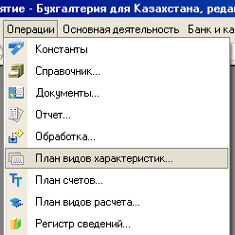

In the appeared window select Typical Subconto Types:

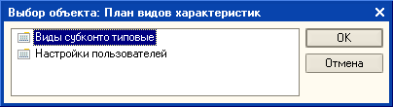

In the current version of the electronic Chart of Accounts there are 3 reserved types of subconto (that can be used as additional analytical levels and selected for each account). The structure of subconto, used in a typical configuration, is defined, on the one hand, by requirements of normative documents regulating the order of analytical accounting procedures (Instructions on using the Chart of Accounts), and on the other hand, by the opportunity of getting accounting results in the context of analytics' objects, both for reporting, and for the internal purposes of the enterprise.

List of subconto that you have opened includes subconto entered in configuration mode, but it is also allowed to add new subconto in user’s mode:

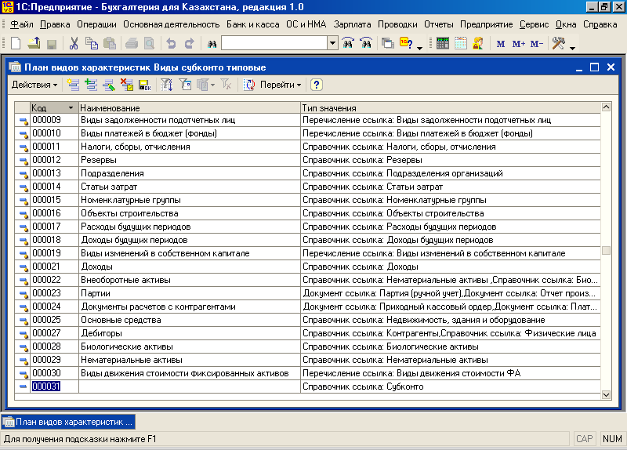

6. Creating New Accounts and Sub-Accounts.
Accounts entered at a system configuration stage (that Chart of Accounts which is offered by default in the given configuration) are inaccessible for removal in a user session. Accounts created in Configuration Mode have a pictogram – blue letter "T" with yellow dot: , and accounts created in user’s session – blue letter "T" without yellow dot: . As it was discussed above, it’s still possible to modify some properties for accounts created at configuration stage while working in user’s mode.
Let's now practice entering a new account into the Chart of Accounts. For example, we want to add an account 8013 “Materials (in production)” to the group 8010 “Main Production”. Open the Chat of Accounts and press button on its toolbar to add a new account. Fill in the appeared dialog as shown on the following picture:
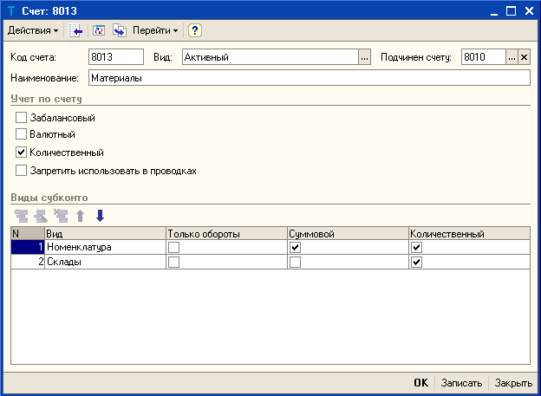

Finally, press button “OK” to save your changes and close the dialog.
To change the account you should use option "Change" from "Actions" menu…
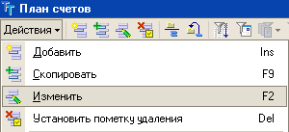
or use , or press [F2] or [Enter], or double click on account’s name.
A new account can be entered into the Chart of Accounts by copying already existing account. To do this it is enough to place cursor on the line with account or sub-account which will be used as a sample, and make one of the following: either press [F9], or click pictogram , located on the Chart of Accounts' window toolbar, or select option "Copy" from the "Action" menu. While copying, data of the new account are automatically filled with data of the current account, and user has an option to modify it at his wish.
In a similar way as you created you first account, you can enter other production accounts:

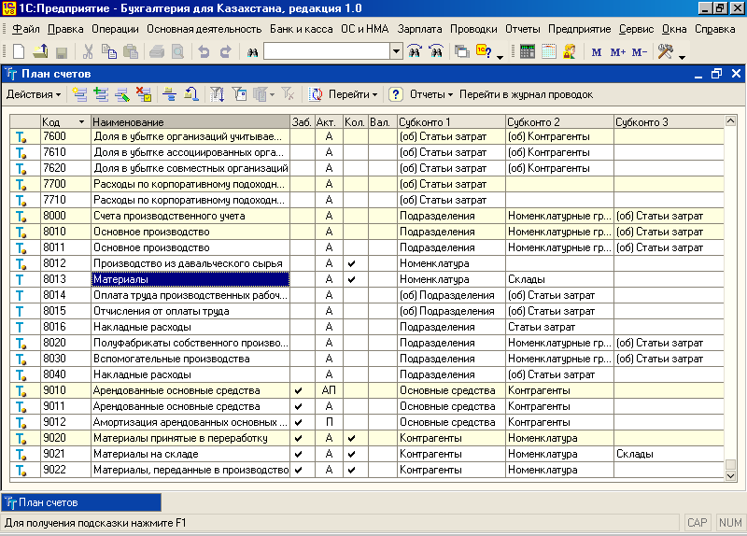

You may later want to delete unnecessary accounts. To accomplish this, right-click on the icon of account you want to delete, and in the pull-down menu select the option "Mark for deletion":

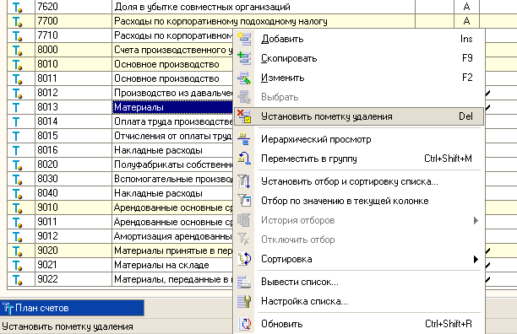
In the appeared dialog answer “YES” to the question “Mark selected object for deletion?”:

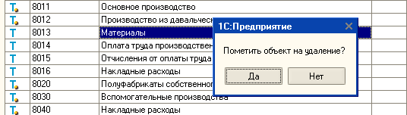

Account’s icon will be marked with a red cross, as shown on the following picture:

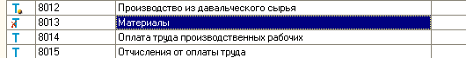

To continue the deletion process, close all opened windows in the program, and select menu Operations => Delete Marked Objects:

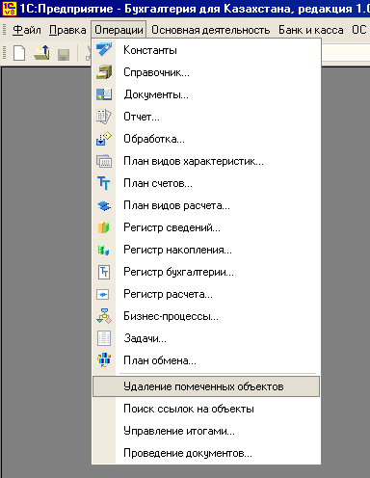

Before you proceed, program will need to check whether selected items can be deleted without loss of data. This is a necessary precaution, as if selected accounts were used in some transactions, upon deletion of accounts related transactions could also be lost. If number of transactions is big, checking all possible relationships in which accounts would be engaged can take a lot of time. You'll see a warning dialog prompting you that checking operation can take some time:

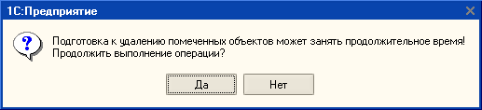

If you agreed, next dialog appears showing all objects selected for deletion (it could be also directories' items, documents, transactions, etc.). All of them will be marked for deletion by default, but if you don't want to delete some of them immediately, uncheck appropriate elements:

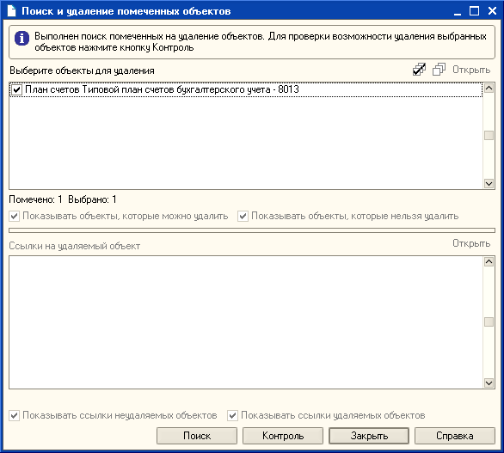

Next step is to check whether selected objects can be deleted or not. Press button "Check", and checking procedure will be started. Upon completion program shows a statistics on how many items could be deleted, and how many cannot. If some items cannot be deleted immediately, you'll be prompted to delete links the specified objects in the bottom part of the dialog:

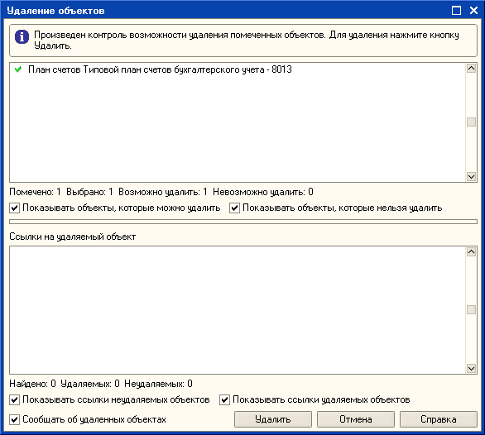

When finished, press button Delete. Information panel at the bottom of program's window shows statistics on deleted objects:

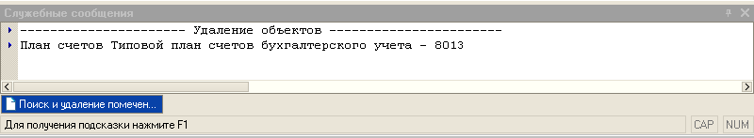

7. International Financial Reporting and Accounting Standards (IFRS/IAS).

As it has already been noticed, knowledge of the Chart of Accounts itself, and even knowledge of correct transactions is not enough to conduct accounting procedures properly. Another important document which you always should be aware of and follow is a set of International Financial Reporting and Accounting Standards (IFRS/IAS). IFRS/IAS are issued by the International Accounting Standards Board (IASB) and regulate every aspect of accounting activities, providing necessary methodological and legislative base.

IASB is full-time, independent, standard-setting body and its members are chosen for their expertise in accounting. Its mission is to create a set of high-quality accounting standards that can be consistently applied worldwide. This is a difficult mission, but the structure and policies of the IASB are well-suited to achieve it. The IASB's standards became mandatory for many listed companies in the EU and other countries beginning in 2005. It was a huge step forward in terms of international convergence in accounting standards. One set of standards is acceptable in something like 100 jurisdictions. It is a great benefit to investors and other financial statements users worldwide.

You can find a complete set of IFRS/IAS (issued at the end of October 2005), as well as methodological recommendations prepared by leading auditing companies on our class web site:

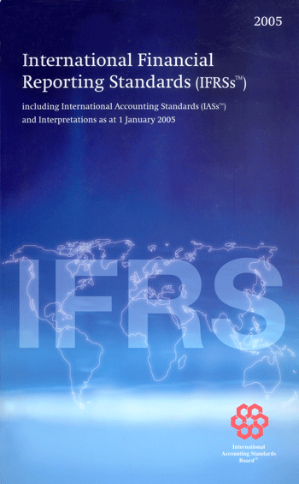 | 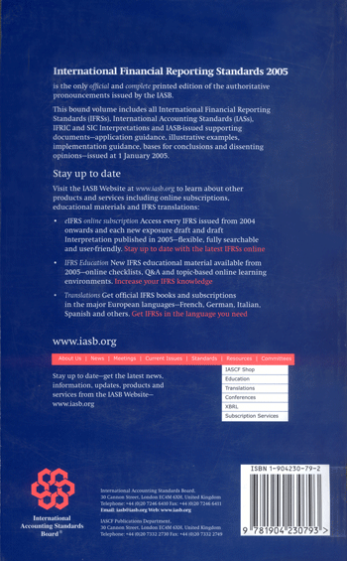

Methodological recommendations to IAS will allow you to understand text of particular standard better by providing set of examples demonstrating concepts discussed in the text of standard itself.
A newer version of 2006 International Financial Reporting Standards (IFRS) Bound Volume (2,400 pages) will be available soon from IASCF shop:

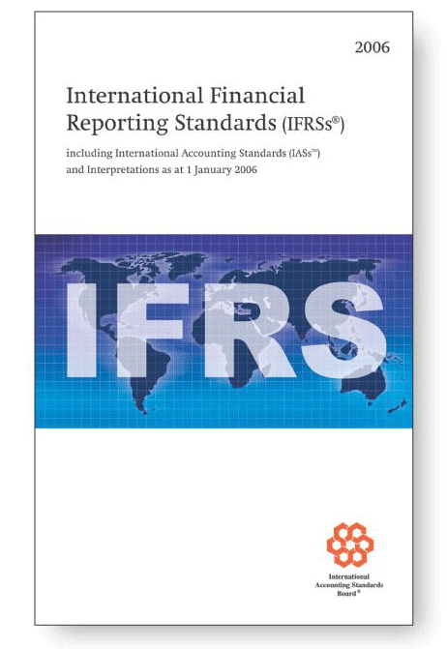
The 2006 International Financial Reporting Standards (IFRSs) Bound Volume provides the complete consolidated text of the latest version of IFRSs/IASs, IFRIC and SIC Interpretations and IASB-issued supporting documents — application guidance, illustrative examples, implementation guidance, basis for conclusions and dissenting opinions — approved at January 1, 2006.
The main changes in this 2006 edition of the Bound Volume are the inclusion of:
- The revised Constitution, approved by the Trustees in June 2005;
- A new standard - IFRS 7, Financial Instruments: Disclosures;
- Amendments to IAS 1 - Capital Disclosures;
- Amendments to IAS 39 Financial Instruments: Recognition and Measurement - Cash Flow Hedge Accounting of Forecast Intragroup Transactions; The Fair Value Option and Financial Guarantee Contracts;
- IFRS 4 Insurance Contracts revised Implementation Guidance;
- Amendments to IAS 21 - Net Investment in a Foreign Operation;
- Three new Interpretations - IFRICs 6, 7 and 8;
- Amendments to other IFRSs resulting from these pronouncements; together with editorial corrections.
- The Glossary of Terms and the Index have been updated.
The volume also includes the IASB Framework for the Preparation and Presentation of Financial Statements, and the Preface to International Financial Reporting Standards.
Starting from January 1, 2006 all Kazakhstan’s companies are obliged to act in accordance IFRS/IAS. This process has begun several years ago when in 2004 Kazakhstan's banks had to move to IFRS/IAS, and in 2005 joint-stock companies (JSCs) had to accept them. This process in not fast, however. A new, 4-digit Chart of Accounts, and new forms of financial reporting (Balance Sheet, Income Statement, etc.) developed according to new standards were accepted only at the beginning of 2006. At initial stage companies were advised to conduct accounting according to Kazakhstan's Accounting Standards (KAS) and IFRS/IAS simultaneously, and later prepare transformation statements. On the other side, developers of accounting software (such as 1C) also need some time to adjust their programs and configurations to requirements of new accounting standards. The first configuration fully realizing new principles of accounting, a new Chart of Accounts, and new forms of financial reporting was released at the beginning of April 2006 on 1C: Enterprise 8.0 technological platform. There are also differences between KAS and IFRS (such as permitted methods for valuation of inventory – KAS includes 4 methods and allows LIFO, while IFRS is not, or valuation of Fixed Assets – under IFRS revaluations of FA and inventory are made on regular basis to ensure that the carrying amount reflects fair market value while under KAS FA may be revalued once in several years and there is no revaluation of inventory) that complicate a transition process. Now, let's get accustomed to the major principles of IFRS/IAS.

7.1. Need for International Accounting Standards.
While differing national traditions and experiences led to the development of alternative financial reporting models, the pressures for intensified development in the global environment have been evident as the needs of the ever-changing economy demand international harmonization. Major changes in business practices following World War II have led to demands for the internationalization of accounting and auditing practices. These changes are found principally in the evolution of multinational enterprises and, more recently, international capital markets. From these
flow numerous professional practice issues.
Multinational companies (MNC) have grown dramatically and over the past thirty-five years have assumed a dominant role in many market segments, affecting almost every country, every government, and every person. From an accounting perspective, the complexity of conducting international business operations across national borders, each with a different set of business regulations and often different accounting methods presents a daunting challenge for accountants and the professional bodies that establish accounting and auditing rules. Some of the significant complexities confronting international accountants are caused by the nature of the huge multinational enterprises themselves. The diversity of applicable accounting, auditing, and tax rules may affect the enterprise's ability to prepare reliable financial information necessary for a careful analysis of investment opportunities. As the number of countries of activity increases, so does the complexity.
Some national differences in accounting and reporting approaches remain and need to be addressed, but the number of such distinctions has diminished markedly. One prime example was the complaint of many US companies about the competitive disadvantage that presumably flowed from the US rules regarding accounting for goodwill. Entities complying with accounting standards of most European countries including the United Kingdom did not need to amortize goodwill, because it could be charged directly against shareholders' equity at the date of the business acquisition. With the recent adoption in the US of SFAS 142, however, there will no longer be any goodwill amortization, so this distinction has been obviated. (In a turnabout, US GAAP now prohibits pooling of interests accounting entirely, whereas previously the US rules were somewhat more lenient regarding use of this method of accounting for business combinations. It is expected that UK and IASB standards may be conformed to this purely purchase-method requirement in the
intermediate term.)
Other international accounting and reporting matters, such as inflation accounting adjustments, deferred tax accounting, and translation of foreign subsidiaries' financial statements, also arguably create disadvantages for some companies, and the persistence of these differences puts pressure on
standard setters to work harder to achieve a level playing field.
The globalization of capital markets has also contributed to the need to address harmonization of financial reporting requirements. Capital needs were once supplied almost exclusively from domestic sources, especially in the pre-World War II era. However, since that time, and especially as a result of major international economic assistance programs after the war, there has been a significant growth and development of international capital markets. There are now highly developed Eurodollar, Eurocurrency, and Asia-dollar capital markets in the developed world economies, especially those in the United States, the United Kingdom, Japan, and parts of Europe. That the financial marketplace is now global is abundantly evident from the October 1987 stock market crash and subsequent crises in Asia and Russia, in which all or many major markets plunged
by similar magnitudes.
This vast global capital market needs but does not yet have a common accounting "language" for the communication of financial information. Recognition of this need is another significant influence and a major force in the development of, and progress toward, internationalized accounting and auditing standards. Without this common language there is some doubt that given diverse national standards, a truly efficient international market will develop, and this may impair the ability of capital-seeking corporations to compete effectively for the capital otherwise available
in the world markets.
National securities regulators, as well as the International Organization of Securities Commissions (IOSCO), an organization of securities regulators promoting international coordination, have recently given increased support to the need for improved international accounting standards, and therefore to the IASC's harmonization efforts. As discussed elsewhere in this chapter, IOSCO's endorsement of IAS for cross-border listings, while qualified, promises greatly increased support for international harmonization of accounting standards. Given the obvious need for global harmonization of financial reporting practices, if not outright uniformity of generally accepted accounting principles, the importance of the IASC's efforts can readily be appreciated.

7.2. Convergence in Accounting Standards.

The IASB and its US counterpart, the Financial Accounting Standards Board (FASB), have been working towards eliminating differences between US GAAP and IFRS to the greatest extent possible. The IASB and the FASB agreed formally in October 2002 to work towards convergence in their standards. The two Boards are now working together on several major projects, and they have essentially decided to coordinate agendas, so that any major project that one Board takes up will also be taken up by the other Board. In addition, the two Boards have been working on "short-term convergence", which involves quickly converging in certain areas to whichever Board's standard is better. That is, this process involves incremental improvements - instead of rethinking the issue entirely, the Boards look at the two existing models, and pick the better one. Many of the changes the IASB made in its recent amendments to previous standards accomplished this goal, and the FASB has put out 4 exposure drafts that would change US GAAP in certain areas to conform to IASB guidance that is considered to be better.

Clearly, the prospect for convergence in US GAAP and IFRS is very good. In addition, the adoption or acceptance of IFRS in many jurisdictions in the near future means, of course, that convergence amongst all of those jurisdictions can also be achieved. That doesn't cover the entire world, but it is a great start.
7.2.1. How International standards affect U.S. companies and GAAP.

- There is a clear trend toward adopting IFRS as the single body of internationally accepted financial reporting standards. In the next few years, thousands of companies will move to IFRS as a primary basis of financial reporting.
- The IFRS mandate will affect U.S. companies. Some may be required to adopt IFRS to meet the reporting requirements of an international parent or investor company, while others may recognize the need to voluntarily supplement their current financial reporting with IFRS to allow for an accurate comparison with foreign competitors.
- A U.S. company will have to report under IFRS if it is the subsidiary of a foreign company that must use IFRS; has a foreign subsidiary that must report according to IFRS; has operations in a foreign country where IFRS use is mandatory; or has a foreign investor that must report according to IFRS.
- The convergence efforts of FASB and the IASB already have changed U.S. GAAP. As these efforts continue, their effects on U.S. GAAP will multiply. Both boards have issued exposure drafts relating to the near-term convergence of their goals, and the IASB has published several statements that narrow the differences between U.S. GAAP and IFRS.

Cross-border investors often find it difficult to understand financial statements that foreign companies prepare using their respective nations’ accounting principles. But greater uniformity and efficiency are coming to the international investment community now that most public companies domiciled within the European Union (EU) will be required to use international financial reporting standards (IFRS). Currently more than 300 SEC-listed companies are headquartered in the European Union and thus are required to use international financial reporting standards beginning in January 2005.

IFRS is a body of accounting and financial reporting standards developed by the International Accounting Standards Board (IASB). Every major nation is moving toward adopting them to one extent or another. The European Union requires their use, the United States and Canada are converging their versions of GAAP with IFRS and some companies in other countries are using them voluntarily.

This trend may dramatically affect the financial reporting of U.S. companies that own, are subsidiaries of or have other relationships with foreign entities directly subject to an IFRS reporting requirement, such as that of the European Union. Many foreign companies registered with the SEC are headquartered in countries that require them to begin using IFRS in 2005; while these companies are subject to the U.S. regulatory environment, they also will have to adopt IFRS. And because U.S. regulators and rule makers are actively supporting convergence, U.S. GAAP will evolve in tandem with IFRS and thus affect even U.S. companies with no overseas ties.

7.2.1.1. Increasing use of IFRS

A growing number of jurisdictions require public companies to use IFRS for stock-exchange listing purposes, and in addition, banks, insurance companies and stock brokerages may use them for their statutorily required reports. So over the next few years, thousands of companies will adopt the international standards.
Countries in many parts of the world already require companies to adopt IFRS or will do so soon. The European Commission (EC)—the European Union’s legislative and regulatory arm—issued a rule that, with a few exceptions, requires all public companies domiciled within its borders to prepare their consolidated financial statements in accordance with IFRS beginning January 1, 2005. This requirement will affect about 7,000 enterprises, including their subsidiaries, equity investees and joint venture partners.

Significantly, EU companies on January 1, 2005, lost the option of using U.S. GAAP for listing purposes on foreign stock exchanges. However, under the EC regulation, EU member states may permit companies to defer adoption of IFRS until 2009 if their shares currently trade on a U.S. stock exchange and they use U.S. GAAP. EU member states also are deciding whether to require or permit the use of IFRS for statutory reporting purposes, such as for the disclosures energy utilities must make to government power authorities.

The increased use of IFRS is not limited to public-company listing requirements or statutory reporting. Many lenders and regulatory and government bodies are looking to IFRS to fulfill local financial reporting obligations related to financing or licensing.

7.2.1.2. Impact on U.S. entities

Although the use of IFRS isn’t required in the United States, the new standards could affect the financial reporting activities of U.S. companies, regardless of their size or of U.S. reporting requirements. The following is a discussion of four possible situations in which a U.S. company would be required to use IFRS.

The U.S. company’s international parent uses IFRS.

If a U.S. company has a parent headquartered outside the United States that reports on an IFRS basis and has shares publicly traded on a European exchange, the subsidiary will have to prepare IFRS information for inclusion in the parent’s consolidated financial statements. In some situations a U.S. company’s financial statements previously may not have been consolidated because its parent’s local version of GAAP did not require it, but that is not so under IFRS.

Consolidated IFRS financial statements must be prepared using uniform accounting policies, so the subsidiary’s accounting policies must conform to its parent’s for like transactions and other similar events, such as the measurement of inventories. Unlike U.S. GAAP, IFRS does not permit inventories to be measured using the LIFO method. Therefore, the U.S. subsidiary would have to gather information on either an (weighted-) average cost or FIFO basis, depending on the parent’s accounting policy.

CPAs who previously prepared financial statements for a U.S. subsidiary of a foreign company have experience converting U.S. GAAP-based financial statements into, for example, equivalents based on French GAAP. These practitioners will, of course, have to familiarize themselves with IFRS as a new basis of accounting.

The U.S. company’s foreign subsidiary uses IFRS.

In a U.S.-headquartered multinational corporation, all subsidiaries that are publicly listed in the European Union must comply with IFRS beginning January 1, 2005. So EU subsidiaries will submit IFRS statements to the parent, which may have to convert them to U.S. GAAP for inclusion in its consolidated financial statements. Consequently, CPAs at the U.S. parent company should be aware of IFRS reporting requirements and identify and resolve any financial reporting issues related to its consolidated financial statements. To ensure their counterparts at subsidiaries are following IFRS reporting requirements, practitioners at the parent company should coordinate subsidiaries’ reporting activities. CPAs also might consider advising U.S. companies in this situation to take the opportunity to simplify their financial reporting processes by settling on IFRS as a uniform set of accounting standards for their foreign subsidiaries around the world.

The U.S. company has foreign operations.

U.S. entities that have or are seeking to establish operations in other countries now may be required by local regulators or lenders to prepare IFRS-compliant statements. This is increasingly common in countries that have adopted IFRS for listing purposes and it shows how far-reaching IFRS reporting requirements may become. CPAs should be alert to and prepared to deal with such situations, of which the following are examples:

- A U.S. company issuing debt or equity in a foreign capital market may be required to prepare IFRS statements.
- A U.S. company may be required by the local government, tax or banking regulator to provide IFRS statements.
- A U.S. company’s foreign customers, vendors or lessors may require IFRS statements.
- A U.S. company acquired by a foreign business may be required to provide IFRS statements to the acquirer or a government regulator.

A foreign investor in a U.S. company uses IFRS.

If a publicly traded EU company—for example, a bank— owns 20% to 50% of a U.S. company and previously accounted for its investment using a form of equity accounting under its local GAAP, the bank will be required, beginning in 2005, to report under IFRS. Consequently, the U.S. company will have to prepare IFRS information for purposes of its investor’s equity accounting. (Cost accounting applies to ownership stakes smaller than 20%; equity accounting is used for investments greater than 20% but not more than 50%; and ownership of more than 50% constitutes control, making the owned entity a subsidiary of its parent.)

There also may be cases where the foreign parent of a U.S. company has an investor that is required to comply with IFRS. For example, let’s assume that a Japanese company is the sole owner of a U.S. subsidiary. The Japanese parent company reports its consolidated financial statements using local GAAP, while the subsidiary uses U.S. GAAP for its local reporting. Let’s further assume that a publicly traded investor based in Spain owns 20% to 50%, inclusive, of the Japanese company. Because that investor will have to file IFRS statements beginning January 1, 2005, it will need IFRS information to account for its investment in the Japanese company. Therefore, in order to apply the equity method of accounting in the Spanish investor’s IFRS statements, the Japanese company and its U.S. subsidiary both would have to prepare IFRS-based information.

Another form of investment - joint ventures - also may have to be accounted for on an IFRS basis if it involves a foreign partner.

7.2.1.3. Benefits for volunteers

In addition to the above cases in which IFRS use is mandatory, CPAs may identify situations when U.S. companies may want to adopt IFRS voluntarily. If such a U.S. company operates in an industry experiencing significant foreign competition, such as banking, insurance, motor vehicle manufacturing, pharmaceuticals or telecommunications, the CPA may advise its management to provide enough IFRS-based information for foreign analysts and investors to be able to compare its performance with that of its peers and consider investing in the company.

7.2.1.4. Convergence

CPAs should be aware that efforts to create global accounting standards not only are changing the role of national standard-setters such as FASB, but also are affecting U.S. GAAP. Greater U.S. participation in the IASB’s activities has influenced its policies more than ever before, as in the development of accounting standards for business combinations. And now the IASB’s standards are about to have a strong impact on U.S. GAAP and financial reporting. Recently FASB and the IASB have formally agreed to converge U.S. GAAP and IFRS. To that end they have begun to coordinate their project agendas, with each board agreeing to undertake projects to amend its current standards. CPAs should stay abreast of these developments to build and maintain their ability to advise their clients and employers on IFRS-related obligations and opportunities.

7.2.1.5. Looking ahead

Given the efforts to converge IFRS and U.S. GAAP and the trend toward adopting IFRS as the single body of internationally accepted accounting standards, CPAs shouldn’t underestimate their impact. While U.S. companies may find it easier to make the transition to IFRS from GAAP than companies reporting under other bases of accounting, adopting IFRS still may have pervasive and fundamental effects on a company’s financial reporting, creating a need and opportunity for CPAs to identify and explain to company management the benefits of and best practices for IFRS.

7.3. Interpretation and Enforcement of Accounting Standards.

Many people, when talking about convergence, tend to focus on accounting standards only. But the application of those standards is equally important. Remember that, even when accounting standards are fully converged, the application of those standards will still be dependent upon accountants and auditors in every jurisdiction around the world. If the application various from country to country, from auditor to auditor, from industry to industry, etc., we will lose much of the benefit of having converged standards. Fortunately, there are many groups that are working to reduce the chances of this occurring. The IASB and its staff are helping, by designing training programs on IASB standards, by putting resources into IFRIC, the IASB's interpretive body, and by doing the best they can to write standards in a clear, concise, understandable manner. And the audit firms have taken up this charge as well. Each of the large firms has strong IFRS training programs, has put resources into developing a core of IFRS technical experts, and has been actively promoting IFRS whenever possible. All of these activities are important if IFRS is to be applied consistently worldwide.

Regulators also have an important role to play with regards to international convergence in financial reporting. This role goes to the interpretation and enforcement of accounting standards. Securities regulators must often determine, quickly, whether a company's proposed accounting is consistent with the relevant standards, in order to decide whether the company should be allowed to sell securities on the public markets. This issue is not new, as regulators have been dealing with similar issues related to national accounting standards for quite some time. Unfortunately, it is also not easy to deal with. Many would suggest that regulators leave interpretation of the standards to the standard-setter - to the IASB, in the case of IFRS. This, however, is not entirely a satisfactory approach. The standard-setting process cannot move as quickly as the capital markets, which means there will always be accounting issues that companies are dealing with that the standard-setters have not yet had time to address. In addition, if the IASB is to maintain its policy of keeping its standard are a fairly high "principles-based" level - with less detail that might be the norm under US GAAP, for example - it will be true that for some issues, the standard-setter will not provide guidance. If, in the absence of guidance from the standard-setter, the securities regulators are to accept any interpretation, investors will be subject to multiple conflicting applications, some of which may not provide transparent information. As a regulator, I do not find this to be acceptable, and I don't believe many other regulators would either.

So we will be in the position of making decisions regarding interpretations of the standards. With the same or similar standards being used in so many jurisdictions, there is the possibility that different regulators will have different views on the correct application of a standard. That type of situation would be detrimental to the capital markets, and would of course, undo some of the gains of convergence in standards. To mitigate against this possibility, regulators are working to develop processes that would encourage consultation amongst regulators, thereby reducing the chances for multiple interpretations.

7.4. Benefits from Convergence of National and International Accounting Standards.

From the standpoint of the users of financial statements (e.g., bankers and investors), it is rather difficult to make relative evaluations of companies that use diverse accounting standards. This tends to restrict the market for the shares of these companies and therefore greatly affects their rankings and attributed value. Today, for most businesses, the biggest opportunities lie in international markets: They have economic activities that extend far beyond domestic markets, they seek investment capital in foreign countries, and they conduct their operations through facilities in foreign lands. It is also fairly evident that in the share market arena, global fighters are emerging as winners, since investors seem to be ignoring domestic competitors and clearly casting their ballots in favor of international champions. Thus, convergence of accounting standards worldwide will greatly help the users of accounting and financial information in making informed economic
decisions about these companies.
From the standpoint of preparers of financial statements, the burden of financial reporting would be greatly lessened with increased harmonization, which would simplify the process of preparing individual as well as group financial statements. It is a well-known fact that multinational groups that have non-domestic subsidiaries have huge added costs of preparation of financial statements. To elaborate the point, consider an example of a company that has a subsidiary that is operating out of Saudi Arabia, with its parent company based in the United Kingdom, and whose shares are listed on the New York Stock Exchange. This company will have to prepare three sets of financial statements:

- Financial statements to comply with the Saudi standards, to meet the requirements of the Saudi Arabian company.
- Financial statements to comply with the consolidation requirements in the United Kingdom.
- Financial statements to meet the registration and filing requirements in the United States.

This means that enormous additional financial costs have to be incurred not only in the preparation of such financial statements but also in getting them audited. Imagine if this company were a multinational corporation (MNC) operating out of fifty countries, most of which had local licensing regulations that required financial reporting to be tailored according to their national standards. The company's accounting travails would then be extremely unpleasant, to say the least. Thus, it is obvious that enormous benefits will emanate from convergence of accounting standards worldwide.

7.5. Reporting Anomalies Resulting from Diversity in Accounting Standards Worldwide.
Significant diversity in accounting standards of different countries not only poses the problem of additional cost to be incurred for financial reporting but could cause other difficulties for multinational companies. For instance, it is quite possible for a transaction to give rise to a profit under the accounting standards of one country, whereas it would require a deferral under the standards of another country. When a multinational company has to report under the standards of both countries, one is amazed to see some extremely odd financial results that could sometimes also be embarrassing. The case of lopsided financial reporting that instantly comes to mind is that of German industrial giant Daimler-Benz AG (before its merger with Chrysler), which sought listing of its shares in the United States in 1993 and ended up reporting a massive loss of $1 billion under US GAAP, when in fact it had reported a profit of $370 million under its own national (German) GAAP.

7.6. Major Differences in National Accounting Standards.
The following analysis is by no means an authoritative study of differences in accounting standards worldwide but is being attempted with the limited purpose of highlighting some of the well-known major differences in accounting standards. Four countries have been chosen for this comparison: the
United Kingdom, the United States, France, and Japan.
1. Measurement subsequent to initial recognition of Fixed Assets (historical cost vs. revaluations). Revaluation is more of a choice than a requirement or stipulation. Even those standards that permit revaluations offer it as an alternative to the historical cost. It is prohibited in countries such as the United States and Japan, and if used would be considered a departure from GAAP. In the United Kingdom and France revaluation of assets is permitted, but not all assets are allowed to be carried at revalued amounts. In the United Kingdom the items that are permitted to be revalued are property, plant, equipment, and investments. In France, revaluations are rare except
when prescribed by law.
2. Timing of recognition vs. deferrals. Recognition of profits and losses causes major differences in financial reporting. Sometimes the method used in recognizing profits or losses could cause differences, and sometimes the number of years over which amortization is spread could cause disparities in the reporting of financial results. Two examples illustrating the foregoing causes of
differences follow.
a. Accounting for goodwill. There is great disparity among standards with regard to the accounting treatment of goodwill. Some countries have traditionally given a free choice of either writing it off to reserves on acquisition or capitalizing and recognizing it on the balance sheet. The other controversy is with regard to the number of years over which goodwill is to be amortized. The following summarizes these differences:

- United States and France. Until mid-2001, both treated goodwill as an asset to be amortized over its useful life. Under former US GAAP, the amortization period was forty years, while in France no set limit is prescribed but shorter periods are used. As of mid-2001, a new requirement in the US (SFAS 142) requires that goodwill no longer be amortized, but rather, that it be reviewed for impairment on a regular basis, with charges to earnings when impairment is found to have occurred.
- United Kingdom. Traditionally, alternatives are allowed: Goodwill could either be written off on acquisition by a charge to reserves (not to the income statement) or capitalized and amortized over its useful life. However, amendments to UK GAAP (FRS10) have modified this approach.
- Japan. Goodwill is capitalized and written off over five years, but this can be extended if a longer life can be justified.
b. Accounting for long-term contracts. Long-term contracts could be accounted for under either the percentage-of-completion method or the completed contract method. Profit recognition under the methods is vastly different. While the completed contract method postpones the recognition of profits until the contact is completed, the percentage-of-completion method recognizes profits during the life of the contract. Following are the methods prescribed under the
various standards:
- United States, France, and Japan. Both methods are permitted.
- United Kingdom. Only the percentage-of-completion method is permitted.

3. Recognition of substance over form in accounting for leases: capital vs. operating
- United Kingdom and United States. Certain categories of leases (called finance leases in the United Kingdom and capital leases in the United States) have to be capitalized (capital value of asset leased is recorded as an asset and future lease payments recorded as liability).
- France. Capitalizing is prohibited, except for consolidated accounts, for which it is optional.
- Japan. Although this treatment is not specifically prohibited, there are no accounting rules on this subject.
4. Financial statement disclosures
a. Related-party transactions
- United States and France. There are significant disclosure requirements on related-party transactions.
- United Kingdom. Traditionally, only details of certain transactions with directors (and other specified personnel) were required to be disclosed. However, with the promulgation of a new standard (FRS8), the related-party disclosure requirements have been broadened.
- Japan. All material transactions with related parties must be disclosed under a footnote captioned "Conditions of Business Group".
b. Segmental information
- United States. Applicable only to publicly held (listed) companies.
- France and United Kingdom. Applicable in the case of all companies.
- Japan. Applicable in the case of listed companies and should be reported by the parent company for the group; to be disclosed in a footnote captioned "Conditions of Business Group".

7.7. Reluctance to Change.

Although everybody is in favor of convergence in the abstract, many may be unwilling to change the way they actually do things solely in the name of convergence. For example, there are 4 exposure drafts out in the US regarding changes to US GAAP that would conform US GAAP to IFRS in certain areas. By and large, the changes are in areas that were not perceived to be major shortcomings in US GAAP, nor are they areas where there was diversity in practice. The changes have been proposed now in an effort to achieve convergence. Some comment letters on these documents have indicated a reluctance to make changes in one or more of the areas covered. Respondents have suggested that these proposals should be put off because of the significant changes already being dealt with in the US financial reporting environment. Others have suggested that rather than adopt the IASB's model, the FASB should seek to find an all new, better model. These are honest concerns, and the FASB will carefully consider them, but they nonetheless impact the speed with which improvements can be made, and convergence can be reached.

In another example, consider the issue of what is commonly referred to as divided responsibility in group audits. The US is one of a very few jurisdictions that allow a primary auditor to disclaim, in the audit opinion, responsibility for a portion of the consolidated entity audited by another auditor. The collapse of Parmalat has brought this issue to the front of many people's minds. If convergence is to be reached in this area, it seems more likely that those jurisdictions that allow divided responsibility would change and prohibit it, rather than the other way around. However, there are several reasons cited in support of keeping divided responsibility, including the potential for increased liability to primary auditors, increases in audit fees, and less work available for local or regional auditors, as opposed to those affiliated with multinational firms. Again, these may all be honest and real concerns, but they raise hurdles to achieving the full benefits of one high-quality set of standards.

Finally, there were concerns that have been expressed in US regarding FASB's proposal to require the expensing of stock options. Many believe that expensing stock options will cause a loss of US jobs, or that valuation models for employee stock options are not sophisticated enough. The US Congress is considering legislation that would prohibit the SEC from recognizing as authoritative a FASB standard that requires the expensing of stock options. Again, the concerns are valid. But again, the consideration of these issues raises the possibility that we will not achieve convergence in this important area of accounting.

It is tempting to think of a single set of high-quality standards are destination that we are aiming for, but it is important that we all remember that the destination in question moves over time. 30 years ago, the conceptual framework for accounting standards didn't even consider fair value measurement as a potential choice. Now, of course, fair value is very often the preferred measurement. Similarly, it was once considered to be obvious that non-auditors could not write effective auditing standards. Now many jurisdictions are increasing the input of non-auditors into the audit standard-setting process. These kinds of changes are to be expected, and come about because we are constantly striving to improve standards to reflect the best thinking. So it is important to understand that accounting and auditing standards, oversight and implementation programs, and other relevant infrastructure elements will continue to evolve and improve over time. And that isn't a bad thing. Rather, it is part of the process of constantly improving things.

7.8. Relevance of IAS to the Developing Countries of the World.
Many developing nations do not have their own national accounting standards. The generally accepted accounting principles (GAAP) that they follow are either the UK, US, or international standards. In certain countries, governments and central banks have made the IAS mandatory. Rather than reinventing the wheel, the adoption of IAS, which are high-quality standards developed after a truly international due process, seems to be a step in the right direction, as it will help the
process of uniformity in international financial reporting.

7.9. Application of IFRS/IAS.

7.9.1. Profit-oriented Entities.
IFRSs are designed to apply to the general purpose financial statements of and other financial reporting by all profit-oriented entities. This includes entities engaged in commercial, industrial,
financial and similar activities.
IFRSs are designed to apply whatever the legal form of an entity but national law or other requirements usually determine the application of accounting standards, including IFRS, to particular entities. For example, the EU IAS regulation applies primarily to companies listed on a stock exchange whereas some countries require all companies, but not other entities, to apply IFRS.
Occasionally the IASC has limited the application of an IAS to certain entities, as it has, for example, with IAS 14 Segment Reporting, IAS 33 Earnings per Share and IAS 34 Interim Reporting.
The application of IFRS to public sector business entities is strongly supported by the IFAC public sector committee. Its guideline Financial Reporting by Government Business Enterprises requires that such entities should present financial statements that conform with appropriate national requirements and IASs (IFAC Public Sector Guideline 1, 9). This guideline was developed with considerable assistance from the IASC; the IFAC working party responsible for the guideline was
chaired by the author as secretary-general of the IASC.

7.9.2. Not-for-profit Entities
IFRSs are not designed to apply to not-for-profit activities in the private sector, public sector or government. The IFAC public sector committee (PSC) is seeking to develop a coherent set of International Public Sector Accounting Standards (IPSASs), based primarily on IASs'. It has published a draft Guideline for Government Financial Reporting which seeks to make government more transparent and therefore more accountable. The draft considered four models of accounting: cash, modified cash, modified accrual and accrual. The project has now moved into its next phase in which the committee is developing accounting standards based on IASs for use in public sector not-for-profit activities. By September 2002, the committee had published the following IPSASs:
IPSAS 1 Presentation of Financial Statements
IPSAS 2 Cash Flow Statement
IPSAS 3 Net Surplus or Deficit for the Period, Fundamental Errors and Changes in Accounting Policies
IPSAS 4 The Effects of Changes in Foreign Exchange Rates
IPSAS 5 Borrowing Costs
IPSAS 6 Consolidated Financial Statements and Accounting for Controlled Entities
IPSAS 7 Accounting for Investments in Associates
IPSAS 8 Financial Reporting of Interests in Joint Ventures
IPSAS 9 Revenue from Exchange Transactions
IPSAS 10 Financial Reporting in Hyperinflationary Economies
IPSAS 11 Construction Contracts
IPSAS 12 Inventories
IPSAS 13 Leases
IPSAS 14 Events After the Balance Sheet Date
IPSAS 15 Financial Instruments: Disclosure and Presentation
IPSAS 16 Investment Property
IPSAS 17 Property, Plant and Equipment
IPSAS 18 Segment Reporting
The PSC has issued exposure drafts of IPSASs based on IAS 24 Related Party Disclosures and IAS 37 Provisions, Contingent Liabilities and Contingent Assets and an invitation to comment based on IAS 36 Impairment of Assets.
7.9.3. Consolidated and Legal Entity Financial Statements
IFRSs apply to both the consolidated and legal entity (separate) financial statements of an entity. The legal entity financial statements alone cannot comply with IFRSs if the entity is required by
IAS 27 to publish consolidated financial statements.
National law or other requirements may require or allow the application of IFRS in only consolidated financial statements. For example, the EU IAS regulation requires only that the consolidated financial statements of listed companies comply with IFRSs. It leaves to EU member states to decide whether to require or allow the use of IFRS in legal entity financial statements. Some member states are likely to continue to require or allow the use of tax rules in legal entity financial statements while requiring the entity to publish consolidated financial statements that
comply with IFRSs.
The publication of legal entity financial statements by an entity that has subsidiaries is not required or may be forbidden in some jurisdictions. In such jurisdictions, the consolidated financial statements are the only published financial statements and techniques such as the equity method and proportionate consolidation may be required in those financial statements even when the entity does
not have subsidiaries.

7.10. Format of IFRSs / IASs.
The IASC adopted a new format for IASs in the early 1990s. This format has been used for all the new and revised IASs adopted from 1992 onwards and for all existing IASs from 1994. It will be adopted by the IASB. The new format links the standards with the related implementation guidance. The IASC also moved footnotes into the main text (particularly footnotes to definitions) and moved explanatory material from definitions to guidance paragraphs.
IASs include paragraphs in bold italic type and IFRSs will include paragraphs in bold type. These paragraphs are the principles (or standards) in the IAS/IFRS. IASs also include, and IFRSs will also include, paragraphs in plain type. These paragraphs are implementation guidance. The different paragraphs have equal authority (Preface, 14).

7.10.1. Principles (Standards).
The principles use the word 'should' in IAS and 'shall' in IFRS. An entity must apply the requirements of the principles to appropriate and material items in order for its financial statements to comply with IFRSs. For example, paragraph 7 of IAS 2 Inventories states: "The cost of inventories should comprise all costs of purchase, costs of conversion and other costs incurred in bringing the inventories to their present location and condition". This means that the cost of inventories must comprise all the costs of purchase, costs of conversion and other costs incurred in bringing the inventories to their present location and condition otherwise the financial statements do not comply with IAS 2. The financial statements would not comply with IAS 2 if, for example, the
entity used a marginal cost approach for the valuation of inventories.

7.10.2. Guidance Paragraphs
These paragraphs do not use the word 'should' or 'shall'. They explain how to apply the principles but are drafted to reflect the fact that the circumstances of an entity may be different from those of another entity. An entity follows the guidance paragraphs in appropriate circumstances otherwise its
financial statements would not comply with IFRSs.
For example IAS 2 includes extensive implementation guidance for the principle in paragraph 7.
The guidance includes the following:
The costs of conversion of inventories include costs directly related to the units of production, such as direct labor. They also include a systematic allocation of fixed and variable production overheads that are incurred in converting materials into finished goods. Fixed production overheads are those indirect costs of production that remain relatively constant regardless of the volume of production, such as depreciation and maintenance of factory buildings and equipment, and the cost of factory management and administration. Variable production overheads are those indirect costs of production that vary directly, or nearly directly, with the volume of production, such as indirect
materials and indirect labor.
This guidance explains what the IASB means by the costs of conversion. However, the guidance is flexible enough to allow for the fact that the actual costs incurred by any one entity may be different from those incurred by other entities. An entity follows the guidance but adapts it to deal with the specific costs of conversion which it incurs. However, its financial statements would not comply with IFRSs if those adaptations meant, for example, that fixed production overheads were excluded
from the costs of conversion.
Another good example of the relationship between a principle and the guidance can be found in IAS 27 Consolidated Financial Statements and Accounting for Investments in Subsidiaries. Paragraph 11, the principle, requires the consolidation of all subsidiaries; failure to consolidate material subsidiaries would mean that the financial statements did not conform to IAS 27. Paragraph 12, the implementation guidance, helps to determine when a parent-subsidiary relationship exists; it
recognizes that control, the determining feature, may arise in different ways.
Guidance paragraphs also deal with the different circumstances which exist in different countries and which are important in order to ensure that like transactions and events are accounted for in a
like way, no matter how they are structured. For example:
- IAS 7 explains when bank overdrafts (which arise only in some countries) are included in cash and cash equivalents in the cash flow statement notwithstanding that they are classified as liabilities in the balance sheet;
- the guidance in IAS 22 points out that legal mergers are a form of business combination and explains how the requirements of IAS 22 are applied to legal mergers; and
- IAS 19 [1993] pointed out that retirement benefit plans are set up and funded (or not) in different ways and explained how the same accounting standards were applied to these different circumstances.

7.11. Benchmark and Allowed Alternative Treatments.
Some IASs include two accounting treatments for like transactions and events with one treatment specified as the benchmark treatment and the other as the allowed alternative treatment. Originally the IASC intended to use the term 'preferred' but switched to the term 'benchmark' because it reflected the intention of identifying a point of reference, rather than a preference. The IASC decided not to require reconciliation from the allowed alternative treatments to the benchmark (preferred) treatments although certain IASs require the disclosure of the effects of using the allowed alternative treatment rather than the benchmark treatment.
It was the IASC'S policy, and is the IASB's policy, to require the use of a single treatment for like transactions and events. Therefore, it is inappropriate for an entity to use the benchmark treatment for certain events and transactions and the allowed alternative for other like transactions and events. This policy was confirmed in SIC 18 but had previously been overturned in SIC 1 on the LIFO /
FIFO issue.

7.12. Fair Value.
The term 'fair value' is used extensively in IASs and in the early 1980s the IASC agreed a definition of the term which has been used in all subsequent IASs. It has been modified only to deal with
liabilities as wells as assets.
'Fair value' is a generic term and is defined as the amount at which an asset could be exchanged, or a liability settled, between knowledgeable willing parties in an arm's length transaction. When an asset is exchanged in an arm's length transaction, the consideration is usually an indication of the fair value of the asset Therefore, most business transactions are carried out at fair value. When the fair value of an asset cannot be determined for an exchange transaction, it may be estimated from
the market value or some other source.
Fair value is an accountant's, rather than a valuer's, term and reflects the fact that such values may need to be determined by reference to sources other than an active market. The International Valuation Standards explain the distinction between the accountant's notion of 'fair value' and the
valuer's notion of 'market value' (IVA 1).

7.13. Disclosure.

IASs use the term 'disclosure' or the instruction 'disclose' in a broad sense, encompassing items presented on the face of each financial statement as well as in the notes which form part of the financial statements. Disclosures required by IASs are made in accordance with the requirements of those IASs and, unless specified to the contrary, such disclosures may be made either on the face of the relevant financial statement or in the notes.

7.14. Major Steps Undertaken by Kazakhstan towards Accepting IFRS/IAS.

7.14.1. Introduction.

The single most important constraint to financial sector development in the transition economies in Central Asia and the Caucasus (CACs) is the small size of the economies. To overcome this constraint, the CACs must integrate their financial markets with each other or larger countries. Although this goal is not achievable in the near future, progress can be made towards integration by harmonizing standards and regulations according to international best practices.

In the area of financial disclosure, the international benchmark is IFRS previously called IAS as promulgated by the IASB. Although training activities for accountants organized and funded by various donor organizations have been conducted in the countries in this region over the past years, most large and medium-sized companies have not yet implemented IFRS even in those countries that have allowed implementation.

Kazakhstan began transition to IAS in 1995 when a Presidential decree required that businesses use Kazakhstan’s accounting standards. These standards, based on IAS, were officially adopted during 1996-1997. Training and conversion activities were supported by donor organizations. As of today, most companies continue to use these standards. In 2002 the Law on Accounting and Financial Reporting replaced the Presidential decree. This law required transition to IAS and/or IFRS beginning 1 January 2004 for JSC and 1 January 2005 for all other companies except for very small businesses. This law was amended to delay the dates for transition to 1 January 2005 and 1 January 2006, respectively.

Banks and financial institutions in Kazakhstan were required to implement IFRS beginning in 2003 (amended to 2004). For several years, banks in Kazakhstan that chose to participate in that country's deposit insurance fund have been required to prepare financial statements using IFRSs as well as Kazakh reporting standards. Starting in 2004, all banks are required to participate in the deposit insurance program. Therefore, all Kazakh banks will prepare IFRS financial statements for 2004. These institutions are now regulated and supervised by a unified financial services agency, the Agency of the Republic of Kazakhstan on Regulation and Supervision of Financial Market and Financial Organizations.

Ministry of Finance of the Republic of Kazakhstan (MOF-KAZ) developed a work plan for the period 2004-2005 to support the transition to IFRS. Key activities in this work plan were issuance of guidance commentaries on individual IFRS, a model chart of accounts, and guidance on accounting policy. Contracting for accountant training was also included.
7.14.2. Compliance of Major Non-financial JSCs for IFRS/IAS.

Prior to 2005, non-financial companies in Kazakhstan were required to comply with KAS, modeled on IAS. Companies with an “A” listing (for bonds or equity) on the Kazakh Stock Exchange (KASE) are required to submit audited financial statements; a number of these companies comply with either IFRS or US GAAP. Approved auditors for “A” listed companies include the “Big Four” international audit firms (PWC, Deloitte, E&Y, and KPMG) and BDO Kazakhstanaudit; all of these firms are capable of assisting their clients in complying with IFRS.

The Director of Accounting and Audit Methodology Department (AAMD) and auditors from the international audit firms agree that most large and medium-size companies in Kazakhstan follow KAS but few companies (other than “A” listed companies) report in compliance with IFRS in addition to the required KAS reporting.
In order to provide appropriate guidance on specific issues encountered in practical transition to IFRS, the professional organizations in the Republic of Kazakhstan should be encouraged to poll their members on IFRS conversion issues throughout the implementation period so that knowledgeable professionals can publish timely articles on how to resolve specific implementation issues.

7.14.3. Constraints to Adopting IFRS/IAS in Kazakhstan.

A major constraint to adoption of IFRS was the lack of a Russian translation of current IFRS. Kazakhstan has its own national language and may be required to translate IFRS to that language, but many accountants rely on the Russian language terminology for accounting terms. In many instances, accounting terms that adequately describe the technical accounting treatments required by IFRS are not common in the national language. Given the history of the region, many more accountants know Russian rather than English (the official language of IFRS). It was, therefore, necessary to have access to the Russian translation of the official standards and interpretations promulgated by the IASB.

The accountants of enterprises implementing IFRS needed the Russian text and the MOF departments responsible for issuing guidance on implementation required it as well.

The most recent IASB approved Russian language translation of IFRS was IAS at 2001. Many significant revisions have been made to the IAS existing in 2001 and new standards have been issued. Implementation of IFRS as codified in 2001 is no longer appropriate. USAID financed and managed a Russian language translation of IFRS 2003 but it was never issued in its entirety. Since substantial changes were made to IFRS for 2004 to form the so-called “stable platform” of IFRS to be used by the EU countries’ adoption of IFRS for listed companies in 2005, it was more valuable to devote attention to translating the “stable platform” (IFRS 2004). USAID supported translation of that edition into Russian as well. It should be noted that the IASCF maintains rights to IFRS and requires that translations conform to IASC standards. IASCF will sanction only one translation into any language. The required review procedure to ensure the quality of translation has been cumbersome for the Russian language translation. Throughout the project, the international and local consultants corresponded with the IASC and the USAID project team responsible for the translation to obtain the official Russian language translation of the IFRS “stable platform”. Although representatives of IASC stated that the translation would be approved soon, it had not yet been issued in September 2005. In the absence of a current Russian translation of IFRS, the domestic Accounting Experts made a major contribution to the implementing agencies in all four countries through their skill in the English language and ability to read and interpret IFRS in their official English form.
The international consultant explored the possibility of arranging translation of summaries of IFRS into Russian language. These summaries which are available on the Deloitte website www.iasplus.org may be duplicated as long as the copyright information is clearly marked on each page. While the summaries do not replace the need for the complete standards, they do provide information that the accountants need now.

MOF-KAZ had developed a plan of activities for transition to IFRS. The plan defined activities to be carried out by AAMD, the tax committee and the department of legal services. A major portion of the plan was development of methodological recommendations on application of each IFRS. The plan also included establishing a web page for IFRS transition, review of laws and statutes for compliance with IFRS, training of MOF-KAZ staff, training of accountants, translation of IFRS into state language (Kazakh), seminars for enterprise accountants, and other items. The majority of the tasks were to be accomplished by AAMD by the end of 2004. Since AAMD had already established an action plan they were focused on accomplishing the tasks defined in that plan rather than additional undertakings. The obstacles deemed by AAMD to need the most urgent attention were:
- Lack of Russian language translation of IFRS; and
- Need for guidance on IFRS and how to implement each of the standards.

Whereas the AAMD was not interested in an action plan for overcoming additional obstacles to IFRS implementation, the Vice Minister of Finance-RK was eager to know international best practice for successful transition to IFRS. The international consultant developed a list of considerations/suggestions for successful implementation of IFRS (or “roadmap”) based on international best practices. This listing included steps necessary to overcome the obstacles to sustainable implementation of IFRS. The timetable in the “roadmap” was formulated so that it did not directly contradict the existing MOF-KAZ action plan although in some cases deadlines were extended

Several suggestions from the best practice “roadmap” that had not previously been included in the action plan were adopted before the end of the project:

- MOF-KAZ interpreted the January 1, 2005 deadline for implementing IFRS in JSCs to mean that companies would be allowed to report according to IFRS in 2005 but that full compliance with IFRS would not be required until January 1, 2006 (annual reports issued in 2009). Since full compliance with IFRS requires comparative financial statements, mandating that companies report in compliance with IFRS beginning in 2005 would require them to restate 2004 in compliance with IFRS. This would entail lengthy reworking of the previous year’s balances and activities. The project team was encouraged by MOF-KAZ’s decision.
- Assistance was requested from EU TACIS to analyze “existing legislative and regulative acts and to produce concrete and workable recommendations on bringing them in compliance with the IFRS”6. The work began in April 2005.
- Changes proposed to the Law on Accounting and Financial Statements in conjunction with the EU TACIS project above included establishment of a “Consultative body on accounting and financial reporting” with many functions of an Accounting Standards Board. The proposed body would be comprised of experienced auditors, accountants, and academicians appointed by MOF-KAZ.

Therefore, MOF-KAZ should revise their action plan for implementation of IFRS incorporating suggestions included in the “roadmap” for successful IFRS implementation, taking care to establish a realistic and achievable timetable.
7.14.4. Developing IFRS Implementation.

Accounting in the Soviet era was highly standardized and included specific instructions for accounting and bookkeeping for each and every transaction. Charts of accounts were standardized throughout all countries and used by all entities. Choices among various acceptable accounting treatments and flexibility to tailor the system to the needs of a particular organization were not allowed. Unlike the former system with its detailed instructions for bookkeeping, IFRS are statements of proper ways to report economic activity. They do not include detailed instructions for implementation, correct bookkeeping entries or which accounts to debit and credit. Although it is hoped that over time accountants in Kazakhstan will be able to use professional judgment in adopting accounting treatments without detailed instructions, this is not possible at the present time. Specific guidance is required.

An additional problem relating to implementing IFRS that is mentioned earlier is the lack of IFRS text material. IFRS are copyrighted materials and even in English (official IFRS language) the bound text or electronic subscriptions are expensive (more than $100). There is a problem with translations because IASCF has stringent translation requirements and pricing policies. The result is that IFRS is being required in these countries but the text of the standards is not available to accountants because of language and price.

Guidance documents (“methodological recommendations”) issued by Ministry of Finance can include much of the information from each IFRS with specific guidance on implementation without violating copyright thereby giving accountants access to the substance of each standard.

The Vice Minister of Finance-RK and the Director of the AAMD placed this task as their highest priority for IFRS’s transition-related activities. Specific implementation guidance documents to be developed listed in the MOF-KAZ action plan were:

- Methodological recommendations (commentaries) for application of 31 individual IFRS;
- Recommendations for developing company accounting policies;
- Recommended chart of accounts and instructions for its use;
- Guidance for industry specific accounting treatments; and
- Revision of recommended forms for source documents.

Methodological recommendations for each IFRS and guidance for developing accounting policies were considered the most urgent need. MOF-KAZ requested that the “Big Four” international audit firms, BDO and professional organizations assist in drafting recommendations. The final methodological recommendation would then be reviewed and approved by an Expert Council appointed by MOF-KAZ before publication. The Director of AAMD requested that the project’s domestic consultant act as coordinator for this activity.

The timetable in the action plan for publishing the guidance documents appeared overly ambitious even with the assistance of the project because of the limited resources in AAMD. The entire department has 20 employees in addition to the Director and Deputy Director for both audit and accounting methodology. Ten employees were assigned to the accounting sub-department, only five to the IFRS division. Most of the staff are recent graduates with little or no practical accounting experience and little knowledge of either IFRS or the English language. (The official language for IFRS is English.) It should be noted that over the year of project implementation in Republic of Kazakhstan, there was considerable turnover in this staff; the most highly experienced staff members in the IFRS division left the department. Note also that although the original timetable required 31 methodological recommendations to be issued by the end of 2004, drafting was not scheduled to commence until the Russian translation of IFRS was available.
Obtaining a recent Russian translation of IFRS was a major problem. MOF-KAZ expected that the IASB sanctioned Russian translation of IFRS would be released in early 2004, but it was delayed and not yet released in the summer of 2005. The most recent Russian Wiley IFRS 2005: Interpretation and Application of International Accounting and Financial Reporting Standards by Barry Epstein, et al. language translation available to the staff was the 2001 version of IAS. Important new standards had been issued after that date and many revisions made to existing standards, some profound. Guidance based on any version of IFRS before the 2004 version (“stable platform”) would be incomplete at best. In some cases it would contain significant errors. In order to provide current IFRS information, the project team:

- Arranged for subscription to the electronic version of IFRS (English language) from the IASCF and Wiley IAS 2004, which provides information on application of IFRS.
- Provided a summary schedule of newly issued standards and changes to existing IAS since 2001.
- Conducted training sessions for AAMD staff in IFRS theory and concepts with emphasis on the “stable platform”.
- Obtained current Russian translations of international accounting textbooks and journal articles pertaining to IFRS for AAMD staff use.

The domestic consultant’s role as coordinator for the methodological recommendations was expanded because of the needs of the AAMD. At the insistence of the Director of AAMD, the methodological recommendations were drafted by AAMD staff (rather than the international public accounting firms or professional organizations). This process required review and significant input from the domestic consultant. Three recommendations were drafted entirely by the domestic consultant due to the complexity of the standard. Each methodological recommendation included:

- An explanation of the standard;
- Guidance on how to apply the standard in Kazakhstan;
- Explanation of how the IFRS treatment differs from KAZAS;
- Illustrations of how to apply the standard using journal entries for both simple and complex cases.

After each draft was complete it was sent to the international public accounting firm (KPMG, Deloitte, Ernst & Young (E&Y), PWC or BDO-Kaz) that had agreed to assist on that particular standard for review and editing. The domestic consultant communicated with the firm to expedite review and resolve questions. Upon receiving the edited recommendation document, the domestic consultant again coordinated review by the deputy director of AAMD and revision of the recommendation. Once this additional revision was complete, the recommendation was submitted to the Expert Council for approval.

After unsuccessful attempts to assemble the Expert Council on a regular basis to consider the recommendations, it was decided that they would communicate by email rather than meet together as a group. Each member had questions and comments on the recommendations submitted. The domestic consultant worked with the AAMD staff, the audit firms and the council members to resolve the issues relating to the commentaries so that a final document emerged that was approved by the council. This was a lengthy process requiring much time and effort by the domestic consultant. Success was due in large part to his thorough knowledge of the standards and diplomatic advice. At the request of AAMD the domestic consultant’s original contract for seven months was extended to ten and then eleven months (through July 2005) to accommodate this work.

At 31 July 2005, 16 methodological recommendations had been approved by the Expert Council for official release. Another 15 had been drafted and were being reviewed by the international auditing firms and/or Expert Council. Materials and guidelines were provided for three additional standards in the process of being drafted by AAMD staff. Arrangements were made with the professional organization CoPAA to review and assist in drafting the recommendations in process at the end of the project.

The project team also provided assistance to AAMD in drafting the Recommendation on Accounting Policy (approved by the Expert Council), revision of model forms for financial statements for companies with state ownership and numerous other issues and accounting treatments. Although the project team assisted in developing the model chart of accounts, the chart has not yet been finalized at that time. Lack of a model chart of accounts made correct application of accounting treatments based on IFRS difficult for enterprise accounts and delayed adaptation of accounting software used by enterprises to record transactions and prepare financial reports.

Therefore, MOF-KAZ should provide further training in IFRS to government staff, especially in AAMD. If rules regarding tender process make contracting for high quality training difficult, MOF-KAZ should request donor aid for such training.

7.14.5. Conducting Workshops for Accountants from Major JSCs.

Training courses on IFRS have been conducted in Kazakhstan for years. Many accountants have been trained but few companies have actually adopted IFRS. It should be noted that compliance with IFRS means adherence to all aspects of every applicable IFRS including comparative data for previous year/s and all necessary notes and disclosures. Although the ultimate goal for major companies in Kazakhstan is full compliance with IFRS, it is not possible for most companies to achieve full compliance in the immediate future. The concept of additional notes and disclosures as required by IFRS is new to companies in the region. International audit firms in the region report that extensive assistance must be provided to client companies in order to develop required disclosures for those companies reporting in full compliance with IFRS or US GAAP (e.g. KASE “A” listed companies). For the purposes of this project “actually adopting IFRS” is interpreted to mean adopting those accounting policies and procedures that are in compliance with IFRS accounting and reporting treatments. While training in IFRS should include information on required notes and disclosures and comparative data required the initial emphasis should be on implementation of proper accounting treatments.

To assist in developing practical training materials, the international consultant provided examples of training programs and IFRS conversion materials developed with ADB assistance in Mongolia and several USAID funded accounting reform projects in countries of the FSU. In addition, each domestic consultant was provided with the most recent practical guide to implementing IFRS published by the World Bank Group.

As it was mentioned earlier, the primary focus of activities in Republic of Kazakhstan was on providing assistance to AAMD in developing methodological recommendations for implementing IFRS. AAMD considered promulgation of this guidance to be a necessary precursor to training on conversion to IFRS. MOF-KAZ’s action plan included conducting seminars for accountants in the regions without help from international donor organizations. The project team understood AAMD’s urgent need for assistance with the methodological recommendations, but nevertheless saw value in conducting at least an initial training for enterprise accountants. The Director of AAMD agreed that assessing the needs of accountants in the major JSCs not already being assisted by international audit firms would assist them to delineate appropriate training for implementation of IFRS. In addition, AAMD was interested in educating government staff in both AAMD and tax departments in the issues that enterprise accountants will face in implementing IFRS.
One three-day training seminar was conducted in Ust’-Kamenogorsk, a city in the Eastern-Kazakhstan’s Region, the third most populous region after Almaty and Karanganda. Ust’-Kamenogorsk was chosen for its wide range of industrial activity. The seminar was conducted in cooperation with the professional organization CoPAA who invited accountants from major joint-stock companies in the area. 31 accountants from 24 JSCs participated in the seminar. At the request of AAMD, 11 regional tax department staff and three members of the Regional Committee on State Property and Privatization as well as two representatives of a major accounting software company were also invited. Two representatives of AAMD participated in the seminar as resources rather than trainers.

The first goal of the workshop was to train accountants from JSCs. Since most JSCs issue financial reports according to KAS (which largely conform to older IAS) the emphasis in the training was on recent changes to IFRS and the requirements of the “Stable Platform”. Topics discussed included the provisions of current IFRS that differ from KAS, required changes in the company’s accounting policy, and IFRS 1: First Time Adoption of IFRS rather than on practical examples of how to convert to IFRS. A model chart of accounts had not yet been approved; therefore AAMD did not want practical case studies included in the program. All approved IFRS methodological recommendations were distributed to the participants.

The second goal of the workshop was to provide an opportunity for accountants to have access to AAMD and tax department staff in order to ask questions and get information on plans for IFRS implementation as well as for AAMD staff to learn what is happening in the field. The participants, especially those from JSCs, actively engaged in the training and asked many questions. Questions were solicited at the beginning of the seminar and at the end of each day as well as during the sessions. The project team and AAMD representatives devoted the time necessary to provide comprehensive answers to each question. Some questions relating to tax issues could not be answered because decisions had not yet been made regarding some of the tax issues relating to IFRS implementation. Participants’ remarks made clear that they placed high value on the opportunity for direct and open communication with MOF-KAZ staff.

The third goal of the workshop was to provide information to AAMD to use in designing specifications for regional trainings financed by MOF-KAZ to be held later in the year. This information was collected as part of the evaluation forms distributed at the end of the training. The accountants were asked to indicate preferred format, duration, and topics for MOF-KAZ IFRS conversion accountant training. This feedback was used by AAMD in the tender offer for the upcoming trainings.

Responding to questions on the evaluation form, accountants specified the following ways that MOF-KAZ could act to facilitate transition to IFRS:

- Hasten publication of methodological recommendations for IFRS.
- Make available Russian translation of current IFRS.
- Increase communication with the public. (Example: MOF-KAZ does not report which guidance documents are in process or when they will be issued.)
- Harmonize tax and financial reporting. (This is a frequent request by former Soviet accountants but is rarely practicable.)
- Establish a web site for information and questions.
- Provide a detailed case example of transition from KAS to IFRS.

Major obstacles to implementation of IFRS noted either during the sessions or in the questionnaires included:

- Need for more guidance from AAMD, especially in terms of a suggested chart of accounts;
- Need for a knowledgeable official body to field questions on IFRS and transition issues; lack of high quality training on current IFRS;
- Lack of availability of Russian translation of IFRS;
- Onerous requirement for parallel accounting during implementation;
- Changes needed to accounting software or cost of new software;
- Contradictions between current Kazakhstan’s legislation and IFRS;
- Lack of qualified auditors and consultants; and
- Lack of support from shareholders for the transition.

Therefore, MOF-KAZ should make the process of IFRS conversion guidance more transparent to the accounting community by publishing clear information on what specific IFRS guidance will be issued and targeted release dates as well as IFRS reporting deadlines. The schedule could be published on the MOF-KAZ website. Without information on what guidance will be issued when, enterprise accountants tend to postpone implementation of IFRS.

In order to facilitate prompt transition to IFRS, MOF-KAZ should begin practical training in how to implement IFRS for enterprise accountants in the regions of Kazakhstan as soon as possible. The training schedule should be planned so that it does not conflict with existing reporting deadlines for JSC accountants.

After the initial training workshops recommended above, MOF-KAZ should facilitate roundtables for enterprise accountants and auditors during the period of transition.

7.14.6. Recommendations.

The following recommendations can be used to further facilitate transition to IFRS in Kazakhstan:

- The government should support additional regional workshops on accounting reform to facilitate exchange of information between countries transitioning to IFRS. If resources are not available donor support should be sought.
- The audit profession should be developed to international standards of quality. Compliance with IFRS can be determined only by an audit of financial statements undertaken by knowledgeable auditors in compliance with international standards on auditing. The education, licensing and practice monitoring of auditors in each country should be evaluated for compliance with international best practices.
- Deficiencies should be remedied. The international donor community should support development of the profession if the government in cooperation with professional associations in each country does not have sufficient resources to do so.
- The professional organizations in Kazakhstan should be encouraged to poll their members on IFRS conversion issues throughout the implementation period so that knowledgeable professionals can publish timely articles on how to resolve specific implementation issues.
- MOF-KAZ is encouraged to revise the action plan for implementation of IFRS incorporating suggestions included in the roadmap for successful IFRS implementation which was prepared under the TA, taking care to establish a realistic and achievable timetable.
- MOF-KAZ should establish and publish a model chart of accounts as soon as possible. If MOF-KAZ decides not to recommend a chart of accounts, it should publicize that fact so that professional organizations like the CoPAA can publish model charts of accounts for companies to use. Without concrete guidance on charts of accounts, enterprise accountants will be very unlikely to fully adopt IFRS.
- MOF-KAZ should provide further training in IFRS to government staff, especially in AAMD. If rules regarding tender process make contracting for high quality training difficult, MOF-KAZ should request donor aid for such training.
- MOF-KAZ should make the process of IFRS conversion guidance more transparent to the accounting community by publishing clear information on what specific IFRS guidance will be issued and targeted release dates as well as IFRS reporting deadlines. The schedule could be published on the MOF-KAZ website. Without information on what guidance will be issued when, enterprise accountants tend to postpone implementation of IFRS.
- In order to facilitate prompt transition to IFRS, MOF-KAZ should begin practical training in how to implement IFRS for enterprise accountants in the regions of Kazakhstan as soon as possible. The training schedule should be planned so that it harmonizes with existing reporting deadlines for JSC accountants.
- After the initial training workshops recommended above, MOF-KAZ is encouraged to facilitate roundtables for enterprise accountants and auditors during the period of transition.

7.15. Abbreviations.

- IASB – International Accounting Standards Board
- IASC – International Accounting Standards Committee
- IASCF – International Accounting Standards Committee Foundation
- IAS(s) – International Accounting Standard(s)
- E – Exposure Draft (IASC)
- ED – Exposure Draft (IASB)
- SOP – Statement of Principles (IASC)
- DSOP – Draft Statement of Principles (IASC)
- IFRS(s) – International Financial Reporting Standard(s) (IASB)
- IPSAS – International Public Sector Accounting Standards
- SIC – Standing Interpretations Committee (IASC) - used for both the committee itself and the interpretations issued by the committee
- SIC D – Draft interpretation issued by the SIC
- EU – European Union
- FASB – Financial Accounting Standards Board
- FAS – Statement of Financial Accounting Standard (USA)
- FEE – Federation des Experts Comptables Europeens
- FRS – Financial Reporting Standard (United Kingdom)
- GAAP – Generally Accepted Accounting Principles
- IAPC – International Auditing Practices Committee
- ISA – International Standard on Auditing
- ICMG – International Capital Markets Group
- IFAC – International Federation of Accountants
- IOSCO – International Organization of Securities Commissions
- IVSC – International Valuation Standards Committee (formerly The International Assets Valuation Standards Committee - TIAVSC)
- IVS(s) – International Valuation Standard(s)
- SSAP – Statement of Standard Accounting Practice (United Kingdom)
- KAS – Kazakhstan Accounting Standard(s)
- USAID – United States Agency for International Development
- JSC – Joint-Stock Company
- CACs – Central Asia and Caucasus
- KASE – Kazakh Stock Exchange
- MOF-KAZ – Ministry of Finance of the Republic of Kazakhstan
- AAMD – Accounting and Audit Methodology Department

7.16 List of IFRS / IAS / IFRIC / SIC.
The list of International Accounting and Financial Reporting Standards (IAS/IFRS) and their interpretations (SIC) is provided in the table below:

# | International Financial Reporting Standard / International Accounting Standard / SIC
IFRS 1 | First-time Adoption of International Financial Reporting Standards
IFRS 2 | Share-based Payment
IFRS 3 | Business Combinations
IFRS 4 | Insurance Contracts
IFRS 5 | Non-current Assets Held for Sale and Discontinued Operations
IFRS 6 | Exploration for and Evaluation of Mineral Resources
IAS 1 | Presentation of Financial Statements (revised July 1997; effective for periods beginning on or after July 1, 1998)
IAS 2 | Inventories
IAS 7 | Cash Flow Statements
IAS 8 | Accounting Policies, Changes in Accounting Estimates and Errors (Note: paragraphs 19-22 of IAS 8 have been superseded by IAS 35)
IAS 10 | Events After the Balance Sheet Date (Revised May 1999; effective for periods beginning on or after January 1, 2000)
IAS 11 | Construction Contracts
IAS 12 | Income Taxes (replaced by IAS 12 [revised 1996], Income Taxes, effective for periods beginning on or after January 1, 1998)
IAS 14 | Segment Reporting (replaced by IAS 14 [revised 1997], Segment Reporting, effective for periods beginning on or after July 1, 1998)
IAS 16 | Property, Plant, and Equipment (revised 1998 by issuance of IAS 36)
IAS 17 | Leases (replaced by IAS 17 [revised 1997], Leases, effective for periods beginning on or after January 1, 1999)
IAS 18 | Revenue
IAS 19 | Employee Benefits (replaced by IAS 19 [revised 1998], Employee Benefits, effective periods beginning on or after January 1, 1999)
IAS 20 | Accounting for Government Grants and Disclosure of Government Assistance
IAS 21 | The Effects of Changes in Foreign Exchange Rates
IAS 23 | Borrowing Costs
IAS 24 | Related-Party Disclosures
IAS 26 | Accounting and Reporting by Retirement Benefit Plans
IAS 27 | Consolidated and Separate Financial Statements
IAS 28 | Investments in Associates (revised 1998 by issuance of IAS 36)
IAS 29 | Financial Reporting in Hyperinflationary Economies
IAS 30 | Disclosures in the Financial Statements of Banks and Similar Financial Institutions
IAS 31 | Interests in Joint Ventures (revised 1998 by issuance of IAS 36)
IAS 32 | Financial Instruments: Disclosure and Presentation
IAS 33 | Earnings Per Share
IAS 34 | Interim Financial Reporting
IAS 36 | Impairment of Assets
IAS 37 | Provisions, Contingent Liabilities, and Contingent Assets
IAS 38 | Intangible Assets
IAS 39 | Financial Instruments: Recognition and Measurement
IAS 40 | Investment Property
IAS 41 | Agriculture
IFRIC 1 | Changes in Existing Decommissioning, Restoration and Similar Liabilities
IFRIC 2 | Members' Shares in Co-operative Entities and Similar Instruments
IFRIC 3 | Emission Rights
IFRIC 4 | Determining Whether an Arrangement Contains a Lease
IFRIC 5 | Rights to Interests Arising from Decommissioning, Restoration and Environmental Rehabilitation Funds
SIC 7 | Introduction of the Euro
SIC 10 | Government Assistance — No Specific Relation to Operating Activities (IAS 20)
SIC 12 | Consolidation — Special Purpose Entities (IAS 27)
SIC 13 | Jointly Controlled Entities — Non-Monetary Contributions by Ventures (IAS 31)
SIC 15 | Operating Leases — Incentives (IAS 17)
SIC 21 | Income Taxes — Recovery of Revalued Non-Depreciable Assets (IAS 12)
SIC 25 | Income Taxes — Changes in the Tax Status of an Enterprise or its Shareholders (IAS 12)
SIC 27 | Evaluating the Substance of Transactions Involving the Legal Form of a Lease
SIC 29 | Disclosure — Service Concession Arrangements
SIC 31 | Revenue — Barter Transactions Involving Advertising Services
SIC 32 | Intangible Assets — Web Site Costs

8. Useful Forms of Documents.

Our class web site provides link to the file containing examples for printable form of documents used in day-by-day accounting work. In particular, you can find forms of documents related to payroll...
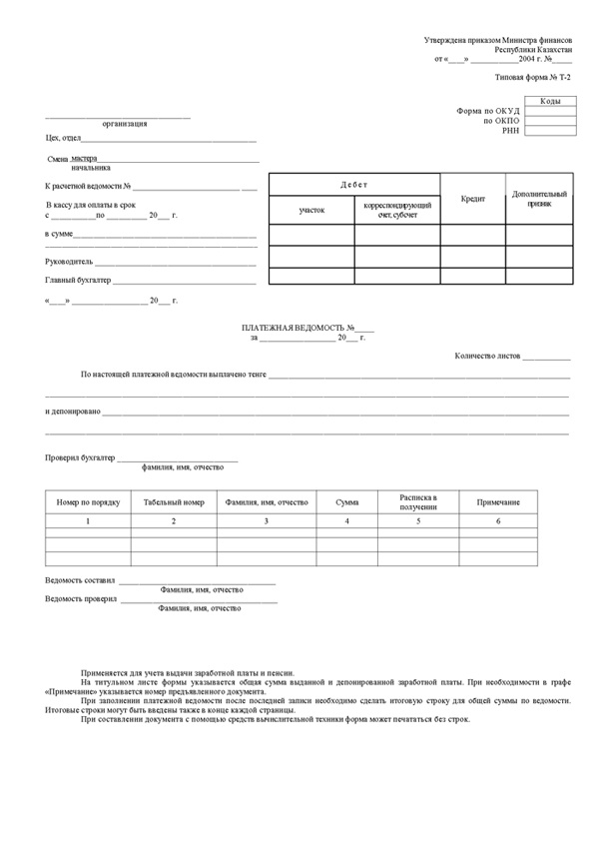

... cash operations...
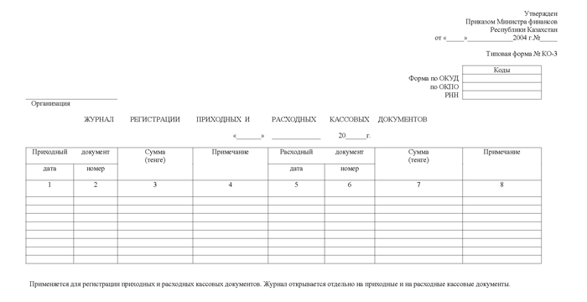

... operation with inventory...
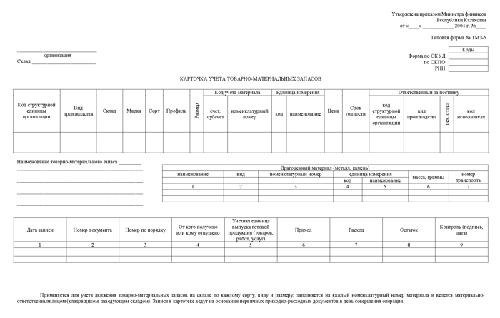

... as well as a full set of acts necessary to conduct properly accounting for Fixed and Intangible Assets, and reflect correctly stock-taking procedures:

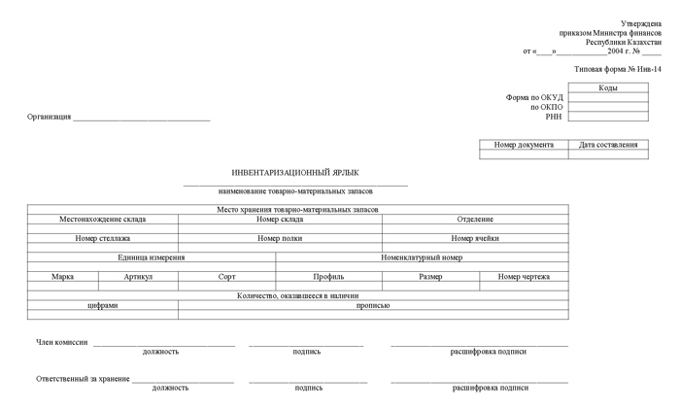

9. An Overview of Kazakhstan's Tax Code.

The next important legislative document regulating the order of tax accounting in Kazakhstan is Kazakhstan's Tax Code:

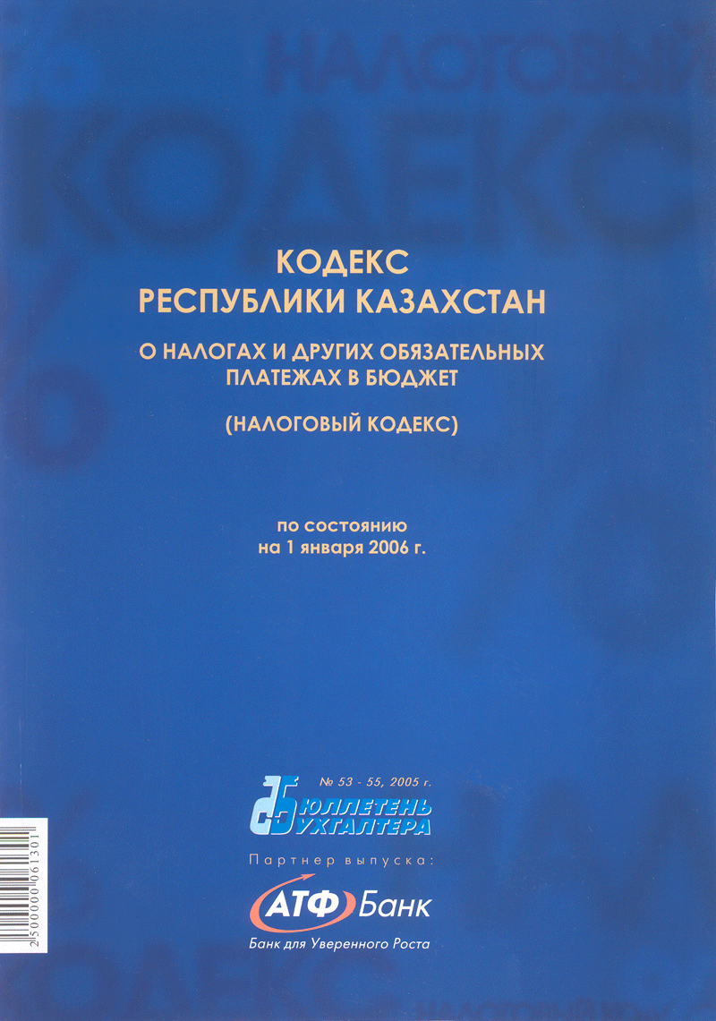

This document was introduced several years ago to incorporate lots of separate instructions regulating the order of computing and paying taxes in Kazakhstan. Now, the most important statements for each kind of tax are presented as a single document:

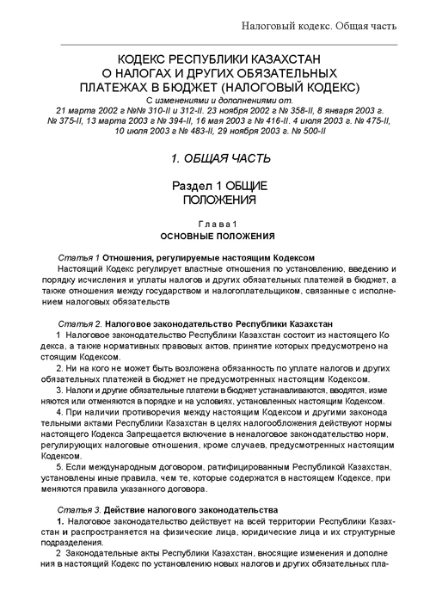

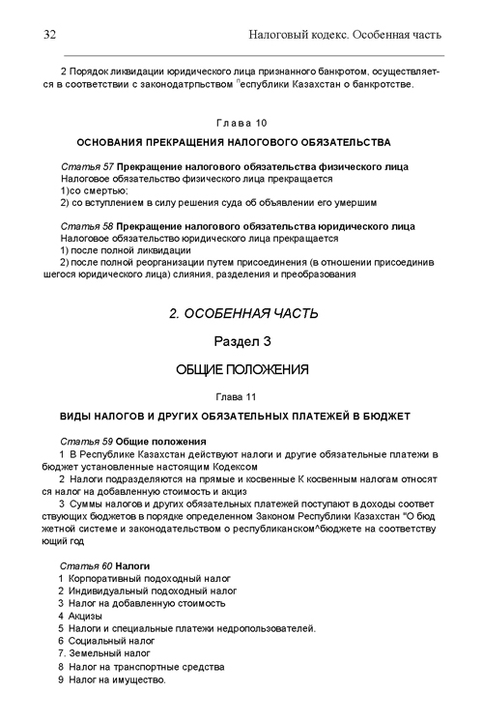

Tax Code provides general legislative base for tax accounting, as well as detailed information on each tax and fee. For those taxes that require separate scales for residents and non-residents, the necessary information is also provided:

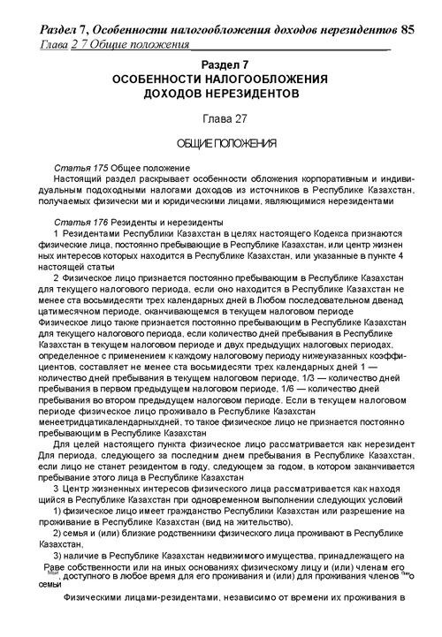

You can quickly find and access information on each particular tax by using the Code's index:
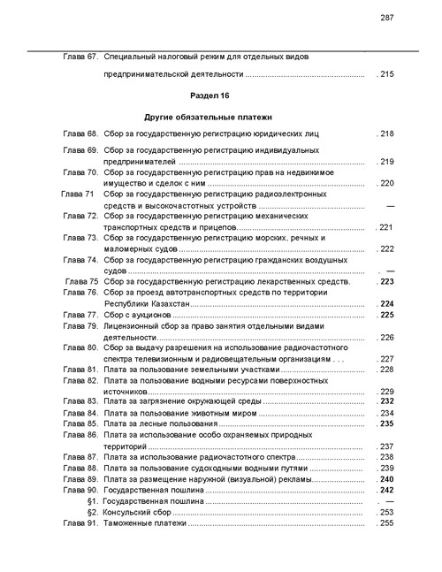
You should also know that amendments to the Tax Code are done on an annual basis. Normally, the updated version of the Tax Code is available in January.

More detailed information on particular taxes can be found in specialized instructions (issued and updated separately from the Tax Code). For example, instruction on computing the Corporate Income Tax has a pretty big volume and, of course, couldn't be incorporated into the Tax Code itself. That is why, to conduct accounting correctly, please be sure that you have an updated versions of all documents discussed above.

NOTE: Tax rates in Tax Code are presented as Monthly Calculated Indexes (MCI) – 1,413 tenge for 2010, or Annual Calculated Indexes (ACI) – 16,956 tenge for 2010.

Finally, let's briefly consider the main principles of tax accounting in Kazakhstan.

10. Main Principles of Tax Accounting In Kazakhstan.
10.1. Kinds of Taxes.
You can receive the prime information about taxes from the document “Tax Code of the Republic of Kazakhstan: On Taxes and other Obligatory Payments to Budget” (Tax Code). Tax Code states that as taxes, it is necessary to pay: Corporate Income Tax, Personal Income Tax, Social Tax, the Value-Added Tax (VAT), Excise taxes, Land Tax, Property Tax, Tax on Vehicles, as well as some other obligatory payments (fees).
As other budget payments there are fees: for state registration of legal entities, for state registration of natural persons, license fee for the right to engage in some types of activity and other fees, as well as fee for outdoor (visual) advertising placement, a state fee, and customs taxes. We will briefly consider the most important provisions below.
10.2. Corporate Income Tax.
The tax provides, in general case that taxable income of bearer is subject to taxation under the rate of 30%. The taxable income is defined as a difference between the cumulative revenue and deductions.
The cumulative revenue of the tax bearer includes all kids of taxes, in particular: the income on realization of goods (operations, services); incomes on leased property; free received property, the executed operations, the services provided; dividends; a favorable exchange difference; prizes; excess of revenues over the expenses received at operation of objects in social sphere and other.
Deductions are costs of the tax bearer connected to receiving cumulative annual income and subject to a deduction from the sum of the cumulative revenue at the moment of calculating the taxable income. For example, in case of business trips the following deductions occur:
- Actual travel expenses to a place of business trip and back, including reservation payment expenses.
- Actual rent costs, including reservation payment expenses.
- Daily allowance paid while on trip within the territory of Kazakhstan, in amount no more than two monthly calculated indexes (МCI) per day (from 01.01.2009 MCI value has been set to a rate of 1,092 tenge).
Deductions also include expense on reception and service of persons, with the purposes of establishment or maintaining of mutual cooperation, as well as for conducting a shareholders’ meeting. Costs associated with organization of banquets, leisure, entertainments or rest are not attributed to representative expense, and are not subject to deduction. Representative expenses are deducted within the limits of norms established by the Government of Kazakhstan. Expenses accrued by the tax bearer on payment of temporary incapacity of workers (sick benefits), maternity leave, on reimbursement of the harm caused to the worker by a mutilation or other damage to health related to fulfillment of the official duties are subject to deduction too. Construction costs and other costs of capital nature, fines and interest are not subject to deduction.
Deductions on fixed assets (fixed and intangible assets) are calculated based on depreciation payments charged to amortization subgroups. Depreciation charges on each subgroup are calculated by application of depreciation rate (cannot be above the limits) to a cost balance of the subgroup. Cost balance of a subgroup of fixed assets is a total amount of cost by the beginning of the tax period, computed as a total amount on the end of previous accounting period decreased by the sum of depreciation charges.
Marginal depreciation/amortization rates for some fixed/intangible assets are shown below:
Type of Fixed Assets | Annual Depreciation Rate, %
Buildings, constructions (except oil and gas wells and transmission devices) | 10
Machines and Equipment (except machines and equipment of oil and gas production) | 25
Office machines and Computers | 40
Fixed Assets not included into other groups | 15

For Corporate Income Tax, period is a calendar year and, if organization has been created after beginning of the calendar year, the first tax period - is a period from state registration up to the end of the calendar year. Advance payments for Corporate Income Tax are done on monthly basis not later than 20th of the current month (see Article 127 of the Tax Code). Taxpayers, not later than on March 31, the year following the accounting period, are to present tax authorities tax declaration and appendices to it, disclosing information on objects subject to Corporate Income Tax, and make final settlements on this tax not later than 10 days after submitting the tax declaration.

10.3. Personal Income Tax.
The Personal Income Tax is paid by the natural persons having incomes, taxable at the source of payment, and incomes which are not taxable at the source of payment. Some kinds of natural persons’ incomes are not subject to taxation. For example, the alimony, received on children and dependents, winnings on lotteries within the limit of 50% from minimum wage; one-time payments for covering medical services, at child birth, burial, which are confirmed by documents, within the limit of 8 minimum wages within the tax year; pension payments from State Pension Fund, etc. Starting from 2009 there is a fixed 10% rate of Personal Income Tax.
NOTE: Prior to 2009 Personal Income Tax was computed according to progressive total method. As an example, please find below scale for computing Personal Income Tax for 2006:
Amount of Taxable Income | Tax Rates
1. Up to 15 Annual Calculated Indexes (up to 185 400 tenge) | 5% from taxable income (up to 9 270 tenge)
2. From 15 to 40 ACI (from 185 400 to 494 400 tenge) | Tax from 15 ACI + 8% from sum exceeding it (9 270 tenge + 8% from sum, exceeding 185 400 tenge)
3. From 40 to 200 ACI (from 494 400 to 2 472 000 tenge) | Tax from 40 ACI + 13% from sum, exceeding it (33 990 tenge + 13% from sum, exceeding 494 400 tenge)
4. From 200 to 600 ACI (from 2 472 000 to 7 416 000 tenge) | Tax from 200 ACI + 15% from sum, exceeding it (291 078 tenge + 15% from sum, exceeding 2 472 000 tenge)
5. From 600 ACI and higher (from 7 416 000 tenge and higher) | Tax from 600 ACI + 20% from sum, exceeding it (1 032 678 tenge + 20% from sum, exceeding 7 416 000 tenge)
There is tax privilege (tax deduction) for Personal Income Tax bearer in the amount of 1 minimum wage for every month within the tax year. Obligatory pension payments to accumulative pension funds (in the amount of 10%), as well as voluntary pension payments are also subject to deduction from the taxable income.
Declaration on Personal Income Tax has to be presented by taxpayers-residents:
- Having incomes which are not taxed at a source of payment, for example, incomes received from leased property;
- Parliament’s delegates of the Republic of Kazakhstan, judges;
- Natural persons having money on accounts in foreign banks outside of Kazakhstan, and some other. (see Article 171 of the Tax Code).

10.4. The Value-Added Tax (VAT).
These are payments to budget from part of the cost on taxable turnover from realization, added up during production and the circulation of the goods (works, services), and also deductions on import of goods on the territory of Kazakhstan. The value-added tax (VAT), payable to budget, is calculated as VAT charged for sold goods, works, services, minus the sum of VAT paid for received (purchased) goods, works, services.
For years 2005-2006 VAT rate was equal to 15% from taxable turnover. In 2009 VAT rate is decreased to 14%, and in consequent years it will be decreased to 13% and 12% respectively. Bearer of the VAT pays the tax to the budget and presents to taxing authority declaration on VAT fulfillment for every accounting period (calendar month).

10.5. Excise Taxes.
Payers of excise taxes are natural persons or legal entities who produce or import excised goods, wholesalers or retailers of petrol or diesel fuel, and others. Excised goods are all this kinds of spirit, alcohol products, tobacco products, sturgeon and salmon caviar, gold, platinum, silver jewelry, cars, fire and gas weapons, and some other. Excised activities are gambling, organization and realization of lotteries. Rates of excise taxes are established by the Government of Kazakhstan.

10.6. Social Tax.
Bearers of the social tax are legal entities, individual businessmen, private notaries and attorneys. The object of taxation: expenses of employer paid to workers in form of incomes in the money or natural equivalent, including incomes provided by the employer in the form of material or social boons, or other material benefits. Obligatory pension payments to accumulative pension funds, payments of grants, and some other are not subject to taxation.
Social Tax is computed according to the regressive scale presented in the Tax Code, separately for residents and non-residents. Individual businessmen, private notaries and attorneys pay Social Tax in the amount of 3 MCI for themselves, and 2 MCI for each worker.
In addition, starting from 2005 companies have to pay money on social insurance (social payments). Social payments’ rate is 1.5% for 2005, 2% for 2006, and 3% for 2009.
10.7. Land Tax.
Land Tax is paid by natural persons and legal entities having taxable objects on an exercised right of property or constant usage, and some other. Taxable object is a land lot.
Base tax rates on grounds of settlements (excluding household land lots) are established in tenge per one square meter of land.
As an example, maximum and minimum rates are:
- Almaty: 28.95 (except for grounds of housing facilities) and 0.96 (for grounds of housing facilities);
- Astana: 19.3 (except for grounds of housing facilities) and 0.96 (for grounds of housing facilities);
- Villages (auls): 0.48 (except for grounds of housing facilities) and 0.09 (for grounds of housing facilities).
Household land lots are subject to taxation for cities of Astana, Almaty and cities of regional importance for area up to 1000 square meters – 0.2 tenge per 1 square meter, and for area above 1000 square meters – 6 tenge per 1 square meter.
Settled lands, occupied by parking places, gasoline stations and markets, are subject to taxation under base rates on the lands of settlements, excluding the grounds of housing facilities, enlarged ten times.
Declaration on Land Tax is presented to tax authorities not later than March 31, year following the accounting period. Legal entities pay current payments not later than on February 20, May 20, August 20, and November 20 of the current year. Natural persons pay Land Tax not later than October 1 of the current year.

10.8. Tax on Vehicles.
Tax on Vehicles is paid by natural persons – owners of vehicles under property right, and legal entities having objects of taxation under the property right, economical or operational management.
Specialized medical transport and mining trucks with carrying capacity of 40 tons and more are not subject to taxation.
Tax calculation is made under the tax rates established in monthly calculated indexes. For cars with volume of engine (in cubic centimeters) up to 1100, the rate is 4 MCI, from 1100 to 1500 cm³ – 6 MCI, from 1500 to 2000 cm³ – 7 MCI, etc., above 4000 cm³ – 117 MCI.
Cargo, special automobiles with carrying capacity (excluding trailers) up to 1 ton – 6 MCI; over 1 ton to 1.5 tons – 9 MCI; over 1.5 to 5 tons – 12 MCI; over 5 tons – 15 MCI.
For automobiles produced in NIS (CIS) countries with an economic life exceeding six years, correction coefficients should be applied:
- From 6 to 15 years inclusively – 0.3;
- From 15 to 25 years – 0.2;
- Over 25 years – 0.1.
On cargo and special vehicles produced in CIS countries with the economic life exceeding seven years, the following correction coefficients are applied:
- From 7 to 14 years inclusively – 0.5;
- From above 14 to 20 years – 0.3;
- Over 20 years – 0.1.
Tax period for calculation and payments of the Tax on Vehicles is one calendar year. Payment of the tax to budget is made at registration place of taxable objects not later than July 1 of a tax period.
Declaration on Tax on Vehicles must be submitted by tax bearers – legal entities not later than March 31, year following the accounting period.

10.9. Property Tax.
Payers of Property Tax are legal persons having taxable object under property right, economic or operating management, and also individual businessmen having object of taxation under the property right on the territory of Kazakhstan. Objects of taxation are Fixed and Intangible Assets. Land, mobile transport, Fixed Assets considered on preservation under the Government of Kazakhstan decision, bridges, tunnels and some other objects are not subject to taxation. The tax base on taxable objects is average annual salvage value, defined on the base of accounting data. The average annual salvage value is an amount equal to one thirteenth of sum calculated by addition of taxable objects’ salvage values on every first day of the current accounting period, and the first day of the month following the current accounting period.
Tax period is the calendar year. Legal entities’ tax rate is equal to 1% from taxable objects’ average annual cost; for individual businessmen tax rate is 0.5%. Property Tax at rate 0.1% from the taxable objects’ average annual cost is paid by exclusive legal entities, for example, noncommercial organizations acting in public interests, having no purpose of receiving income and not distributing this net income or property between participants, excluding religious associations.
Legal entities pay current payments not later than on February 20, May 20, August 20, and November 20 of the current year. Declaration on Property Tax should be submitted not later than March 31 of the year, following the accounting period.
Property Tax for natural persons is estimated based on tax rates and depending on property cost. Please, find below some examples:
- Up to 1 million tenge inclusively – 0.05%;
- From 1 million tenge up to 2 million tenge – 500 tenge + 0.08 % from the sum exceeding 1 million tenge;
- From 2 million tenge up to 3 million tenge – 1,300 tenge + 0.1 % from the sum exceeding 2 million tenge, etc.
- Above 10 million tenge – 23,300 tenge + 0.5% from the sum exceeding 10 million tenge.
Calculation of tax on taxable objects of natural persons is made by tax authorities not later than August 1 of the tax period. Payment of the tax is made not later on October 1 of the current tax period.

10.10. Special Taxation Regime for Small Business Enterprises.
Small business enterprises – natural persons and legal entities – can independently select one of presented below orders of calculation and tax payment, and tax reporting:
- General regime;
- Special taxation regime on the basis of single coupon;
- Special taxation regime on the basis of patent;
- Special taxation regime on the basis of simplified declaration.
a) Special taxation regime on the basis of single coupon is applied to natural persons whose activity bears episodic character, i.e. is done in general no more than 90 days in one year. Natural persons engaged in activity on a single coupon basis without hiring of independent labor, do not pay social tax and free from state registration as individual businessman. The cost of single coupons is established by local representative bodies.
b) Special taxation regime on the basis of the patent is applied to individual entrepreneurs not using hired labor force, organized in the form of personal business and whose income does not exceed 2 million tenge for each 12 month of using special taxation regime. The patent is issued for the period of not less than one and not more than 12 month. To receive the patent individual businessman presents to tax authorities application specifying type of activity, Certificate on state registration as an individual businessman, and documents confirming payment for patent, transfer of obligatory pension payments, as well as social payments. Tax authorities grant the patent in one-day term after submission of the application and receipt of documents confirming payment to budget cost of patent, obligatory pension payments to pension funds, and social payments. The individual entrepreneur calculates patent cost applying 2% rate to the stated income.
c) Special taxation regime on the basis of simplified declaration is applied to small business enterprises under the following conditions:
- Individual businessmen, whose average number of workers, including the businessman himself, equals 25, and marginal revenue to 10 million tenge;
- Legal entities whose average number of workers for the tax period equals to 50, and marginal revenue to 25 million tenge.
Small business enterprise independently calculates taxes on the basis of simplified declaration applying appropriate 3% tax rate. (for more details see Article 377).
The simplified declaration must be presented to tax authorities not later than on the 20th of a month, following the reporting tax period. Payment of taxes to budget is made on time not later than on 25th of the month, following the month after reporting tax period, by equal installments of Personal (Corporate) Income Tax and Social Tax.
10.11. Special Taxation Regime for Particular Kinds of Entrepreneurial Activity.
Special taxation regime is applied to gambling business, gambling machines, bowling, carting, billiards, and lotto game business. The simplified regime of tax calculation and payment allowing submission of fixed cumulative tax, excises, and tax declaration only is established. Rates of the fixed total tax from the unit of taxable object are established by local representative bodies. Sums of excise tax and fixed cumulative tax are subject for payment to budget monthly, not later than on 20th of the month, following the reporting month.

Recommended Readings:
1) Закон РК О Бухгалтерском Учете (handout)
2) Бухгалтерский Учет (Краткий курс) (handout)
3) Инструкция (основа) по разработке рабочего плана счетов бухгалтерского учета для организаций, составляющих финансовую отчетность в соответствии с МСФО (handout)
4) Корреспонденция счетов по МСФО, ч. 1-2 + Примеры корреспонденций счетов Рабочего плана счетов по МСФО (handouts)
5) IFRS/IAS + Методические рекомендации (web)
6) Налоговый Кодекс РК 2010 (web)

